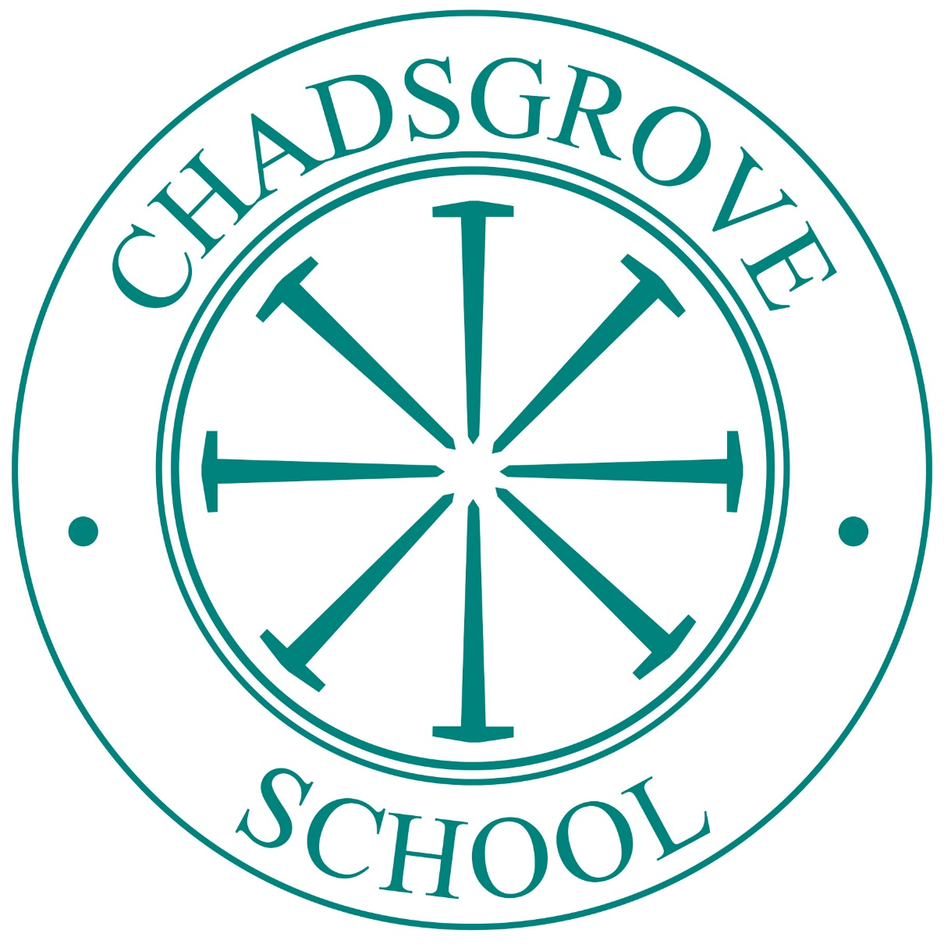

School Uniform Policy

September 2024
POLICY No. 27
DATE APPROVED BY GOVERNING BODY: 3.10.2019
DATE OF NEXT REVIEW: SEPTEMBER 2020
LEAD: Angela Macvie
GOVERNOR RESPONSIBLE: Mark Taylor
POLICY No. 27
DATE APPROVED BY GOVERNING BODY: 3.10.2019
DATE OF NEXT REVIEW: SEPTEMBER 2020
LEAD: Angela Macvie
GOVERNOR RESPONSIBLE: Mark Taylor

POLICY No. 112

DATE APPROVED BY GOVERNING BODY: 30.9.2024

DATE OF NEXT REVIEW: September 2027

LEAD: Louise Beckley

GOVERNOR RESPONSIBLE: Full Governing Body

Contents

1. Aims 3

2. Our school’s legal duties under the Equalify Act 2010 3

3. Limiting the cost of school uniform 3

4. Expectations for school uniform 4

5. Expectations for our school community 4

6. Monitoring arrangements 6

7. Links to other policies 6

1. Aims

1.1 Chadsgrove School aims to:
- Set out our approach to requiring a uniform that is of reasonable cost and offers the best value for money for parents carers
- Explain how we will avoid discrimination in line with our legal duties under the Equality Act 2010
- Clarify our expectations for school uniform

2. Our school’s legal duties under the Equality Act 2010

The Equality Act 2010 prohibits discrimination against an individual based on the protected characteristics, which include age, sex, disability, race, religion or belief, pregnancy and maternity, and gender reassignment. To avoid discrimination, our school will:
- Avoid listing uniform items based on sex, to give all pupils the opportunity to wear the uniform they feel most comfortable in or that most reflects their self-identified gender
- Make sure that our uniform costs the same for all pupils
- Allow all pupils to have long hair (though we reserve the right to ask for this to be tied back)
- Allow all pupils to style their hair in a way that is appropriate for school and makes them feel most comfortable
- Allow pupils to request changes to swimwear for religious reasons or if they are experiencing discomfort related to their sex, gender or gender reassignment
- Allow pupils to wear headscarves and/or other religious garments
- Allow pupils with sensory or physical needs to make reasonable adaptations to their uniform depending on their specific needs
- Allow for reasonable adaptations to our policy on the grounds of equality by asking pupils or their parents carers to get in touch with Chadsgrove School Office, who can answer questions about the policy and respond to any requests. These will be considered on a case-by-case basis

3. Limiting the cost of school uniform

This policy takes into account factors such as:
- The socio-economic status of our school community
- Pupil demographics
- The uniform of neighbouring schools or schools in our Trust
- The views of our school community

Our school has a duty to make sure that the uniform we require is affordable, in line with statutory guidance from the Department for Education (DfE) on the cost of school uniform.
We understand that items with distinctive characteristics (such as branded items, or items that need to have a school logo or a unique fabric/colour/design) cannot be purchased from a wide range of retailers and that requiring many such items limits parent carers ability to ‘shop around’ for a low price.
We will make sure our uniform:
- Is available at a reasonable cost
- Provides the best value for money for parent carers

We will do this by:
- Carefully considering whether any items with distinctive characteristics are necessary
- Limiting any items with distinctive characteristics where possible
- Limiting items with distinctive characteristics to low-cost and/or long-lasting items
- Considering cheaper alternatives to school-branded items, such as logos that can be ironed on, as long as this doesn’t compromise quality and durability
- Avoiding specific requirements for items pupils could wear on non-school days, such as coats, bags and shoes
- Keeping the number of optional branded items to a minimum, so that the school’s uniform can act as a social leveller
- Avoiding different uniform requirements for different year/class/house groups
- Avoiding different uniform requirements for extra-curricular activities
- Considering alternative methods for signaling differences in groups for interschool competitions, such as creating posters or labels
- Making sure that arrangements are in place for parent carers to acquire second-hand uniform items. Parent Carers can speak with the main School Office or our Family Support team
- Avoiding frequent changes to uniform specifications and minimising the financial impact on parent carers of any changes
- Consulting with parent carers and pupils on any proposed significant changes to the uniform policy and carefully considering any complaints about the policy

4. Expectations for school uniform

Our school’s uniform consists of:
- Navy sweatshirt or cardigan with school logo
- Navy polo shirt with or without school logo (white polo shirts are acceptable and available from the school office and can be worn until they are no longer wearable)
- Black or grey trousers/joggers or black or grey skirt

We request that pupils in Post 16 wear smart casual clothing and definitely no vest tops or revealing clothing.

Our school uniform can be purchased at:
S&H Schoolwear and Sports in Bromsgrove. More information can be found at https://www.sandhschoolwearandsports.co.uk/
We do have a small supply of brand new uniform in school which we are selling at a vastly reduced price. Please contact the School Office if you would like more information regarding this.

Expectations of our school community

Pupils:
Pupils are expected to wear the correct uniform at all times (other than specified non-school uniform days) while:
- On the school premises
- Travelling to and from school
- At out-of-school events or on trips that are organised by the school, or where they are representing the school (if required)

Pupils are also expected to contact Deb Rattley, Headteacher, if they want to request an amendment to the uniform policy in relation to their protected characteristics.

Parents Carers:
Parents carers are expected to make sure their child has the correct uniform and PE kit, and that every item is:
- Clean
- Clearly labelled with the child’s name
- In good condition

Parent carers are also expected to contact Deb Rattley, Headteacher, if they want to request an amendment to the uniform policy in relation to:
- Their child’s protected characteristics
- The cost of the uniform

Parent carers are expected to lodge any complaints or objections relating to the school uniform in a timely and reasonable manner. Disputes about the cost of the school uniform will be:
- Resolved locally
- Dealt with in accordance with our school’s complaints policy

The school will work closely with parent carers to arrive at a mutually acceptable outcome.

Staff:
Staff will closely monitor pupils to make sure they are in correct uniform. They will give any pupils and families breaching the uniform policy the opportunity to comply, but will follow up with the Headteacher if the situation doesn’t improve.
Ongoing breaches of our uniform policy will be dealt with following our school’s Behaviour Policy.
In cases where it is suspected the financial hardship has resulted in a pupil not complying with this uniform policy, staff will take a mindful and considerate approach to resolving the situation.
  - Governors:
The Governing Board will review this policy and make sure that it:
- Is appropriate for our school’s context
- Is implemented fairly across the school
- Takes into account the views of parent carers and pupils
- Offers a uniform that is appropriate, practical and safe for all pupils

The board will also make sure that the school’s uniform supplier arrangements give the highest priority to cost and value for money, for example by avoiding single supplier contracts and by re-tendering contacts at least every 5 years.

Monitoring arrangements
The policy will be reviewed every 3 years by Deb Rattley, Headteacher. At every review, it will be approved by the Governing Board.

- Links to other policies
This policy is linked to our:
- Behaviour Policy
- Equality Information and Objectives Statement
- Anti-bullying Policy
- Complaints Policy

