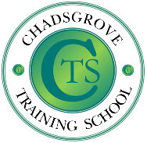**Chadsgrove Training School**

**Continued Professional Development Programme Spring 2025**

Chadsgrove Training School is pleased to be offering a range of courses for the 2025/26 academic year. Courses are relevant to Special and Mainstream providers. There is a variety of face to face and online training available.

|  |  |  |  |
| --- | --- | --- | --- |
| **Course** | **Date Time** | **Provider** | **Cost** |
| Autism in the Early Years | 11th Mar 25 4-5.30pm | Iain Chatwin **Online** | **£45** |
| Including Pupils with ADHD in Primary Schools | 19th Mar 25 4-5.30pm | Iain Chatwin **Online** | **£45** |
| 'A Beginners' Guide to Reading in the Pre-Formal Curriculum' | 3rd April 25  12.45 – 3.15pm | Melanie Bullivant Sam Mole  **Face to Face** | **£65** |
| Lego-Based Therapy | 2nd Apr 25 9.30-12pm | Iain Chatwin **Face to Face** | **£65** |