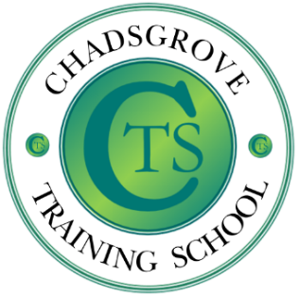
Samantha Mole. BA (Hons)
Professional Studies in Education. Samantha has taught at Chadsgrove School for the past 4 years and has Postgraduate Certificate in Language, Literacies and Dyslexia from the University of Birmingham. She is a class teacher for the Pre-Formal Curriculum Department at Chadsgrove as well as Lead for Pupil Voice. Prior to her role in special education, she was a class teacher within the Foundation Stage and Key Stage 1 and worked as a Reading Recovery Teacher, Every Child a Reader (ECaR) with a Primary School. Samantha was also an Associate Lecturer for University of Worcester teaching on Foundation Degree Courses in Early Years and Learning Support.

Melanie Bullivant. BA, MEd.
Melanie has taught at Chadsgrove School for the past nine years and has a Masters Degree in the education of pupils with Profound and Multiple Learning Difficulties from the University of Birmingham. She is the Phase Leader for the Pre-Formal Curriculum Department at Chadsgrove as well as the Subject Leader for Religious Education. Melanie qualified as a mainstream primary teacher in 2004; prior to her role in special education, she was a class teacher in two different primary schools in Birmingham.
This training will be face-to-face at Chadsgrove School, Meadow Road, Catshill, Bromsgrove, Worcestershire B61 0JL

Please complete and return the booking form overleaf or contact the school
Email: courses@chadsgrove.worcs.sch.uk
Tel: 01527 871511
Wednesday 8th May 2024 9.30am to 12.30pm
Chadsgrove School
£65 per delegate

This course is designed for teachers who are new to working with pupils with Profound and Multiple Learning Difficulties. What does 'reading' look like for our pre-formal learners? This course will give you an insight into some of the ways in which pupils with PMLD can access 'reading' activities, with a focus on sensory storytelling. There will be an opportunity to observe a sensory story in a pre-formal class and guidance on how to plan and deliver your own sensory stories.

Chadsgrove Training School
An Introduction to Reading and Sensory Story Telling for Pre-formal Learners

SEND
Professional Development

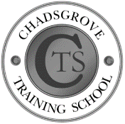
Chadsgrove Training School

Course Title: An Introduction to Reading and Sensory Story Telling for Pre-Formal Learners
Training Date: 8th May 2024
(Course led by: Melanie Bullivant and Sam Mole)
Number of Places Required (£65 each):
Attendee(s) Name & Email Address

The information you provide in this form will be used solely for processing your course booking. If you wish us to retain your email address to contact you about future CTSA professional development opportunities please tick this box
Occupation:
Special Requirements:
(e.g. dietary, access, etc.)
Organisation name:
Postal Address for Correspondence:
Invoicing Address (if different to Postal Address):

Email:
Telephone Number:
Total Cost:

(Please make cheques payable to Worcestershire County Council)
Cost Centre for Internal Transfer for Worcestershire Schools. Please complete both sections below.

Project Code: Cost Centre:
Authorised Signature (Headteacher): | Name:
We regret that we cannot accept typed signatures. Digital signatures or scanned electronic copies are suitable.
Please return to:
Chadsgrove Training School, Meadow Road, Catshill, Bromsgrove, Worcestershire, B61 0JL

Tel: 01527 871511 Email: courses@chadsgrove.worcs.sch.uk
In the event of unforeseen circumstances, we reserve the right to cancel or alter parts of the programme.

