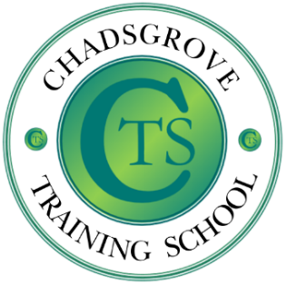

This course will introduce the use of stories to address social understanding difficulties encountered by young people on the ASD spectrum. Stories can be a powerful tool in positive behaviour intervention when written for specific individuals as narratives to describe situations, skills or concepts that they find difficult in relation to social settings.

Participants will be introduced to the guidelines that define effective stories to support them to begin writing stories for use with individuals they work or live with.

**1st July 2025**

9.30.00a.m.– 12.00p.m.

**£65 per** delegate

Email: courses@chadsgrove.worcs.sch.uk

Tel: 01527 871511

*Please complete and return the booking form overleaf or contact the school*

Course content:

● Structuring stories, defining sentence function, and using appropriate phrasing

● Individualising stories

● Effective strategies for introducing and presenting the story

**Chadsgrove Training School**

For Mainstream & SEN

Course led by **Iain Chatwin**

**Writing Social Stories for Children with ASD**   
to Develop Social Competence for

Pupils with ASD

**Professional Development**



Chadsgrove Training School

|  |  |  |  |  |  |
| --- | --- | --- | --- | --- | --- |
| Course Title: **Writing Social Stories (**Course led by: Iain Chatwin)  1st July 2025 **Number of Places Required** (@ £65 each): | |  | | | |
| Attendee(s) Name & Email Address | | | | | |
| The information you provide in this form will be used solely for processing your course booking. If you wish us to retain your email address to contact you about future CTSA professional development opportunities please tick this box | | |  |  |  |
|  |
|  |
| Occupation: | | | | | |
| Special Requirements:  (e.g. dietary, access, etc) | | | | | |
| Organisation name: | | | | | |
| Postal Address for Correspondence: | | | | | |
| Invoicing Address (*if different to Postal Address*):  Email:  Telephone Number: | | | | | |
| Total Cost:  *(Please make cheques payable to Worcestershire County Council)* | | | | | |
| Cost Centre for Internal Transfer for **Worcestershire Schools**. Please complete **both** sections below.  Project Code: Cost Centre: | | | | | |
| Authorised Signature (Headteacher): | Name: | | | | |
| *We regret that we cannot accept typed signatures. Digital signatures or scanned electronic copies are suitable.* | | | | | |

*Please return to:*

Chadsgrove Teaching School, Meadow Road, Catshill, Bromsgrove, Worcestershire, B61 0JL

Tel: 01527 871511 Email: courses@chadsgrove.worcs.sch.uk

**In the event of unforeseen circumstances we reserve the right to cancel or alter parts of the programme.**