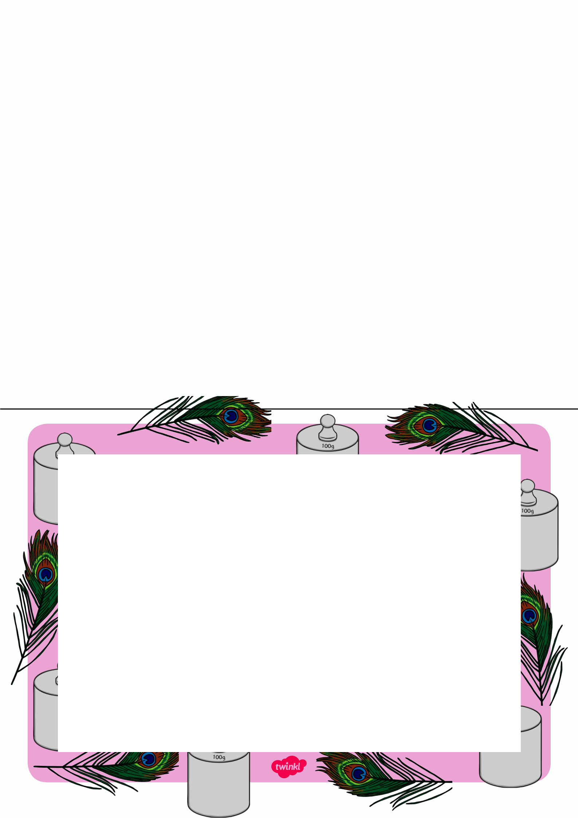
Weight Treasure Basket Sorting

You will need to:

- Collect the items for the treasure basket.
- Find an old box or washing basket to use
- Try filling it with different objects

Busy Bag

Weight Treasure Basket Sorting

What can you find in the basket?

Which things are heavy?

Which things are light?

Can you sort them into two piles?

Are the heavy things easy to lift?

Which is the heaviest thing in the basket?

Which is the lightest?

