 

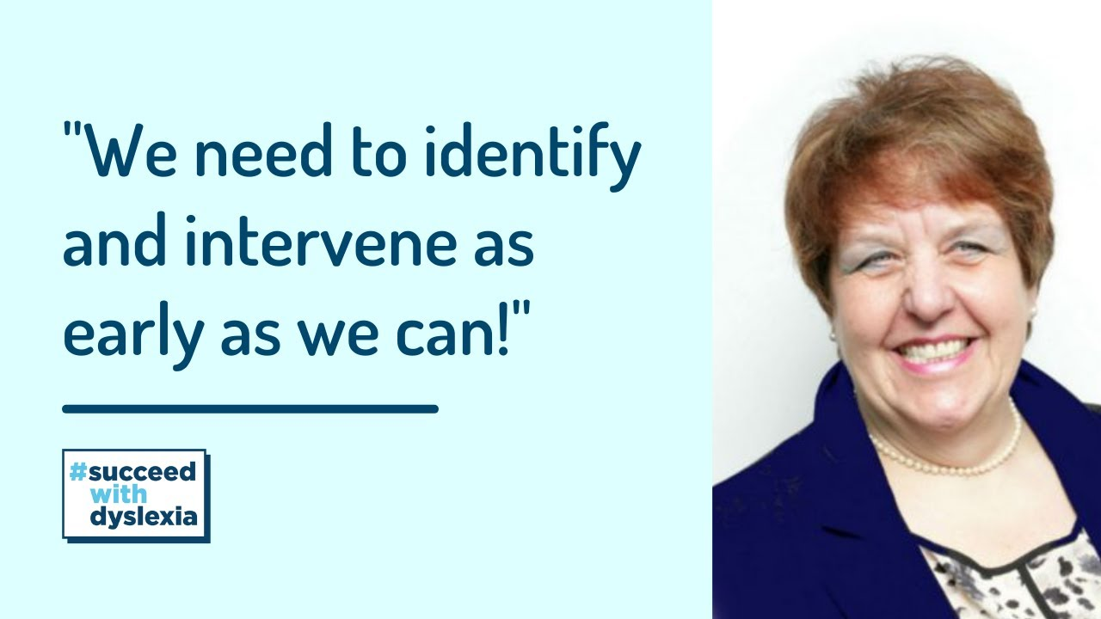

**Course Led by Lorraine Petersen**

Lorraine spent the first 25 years of her career as a teacher and headteacher in primary schools within the West Midlands. In 2004 Lorraine was appointed as the CEO of Nasen (The National Association for Special Educational Needs) where she worked for nine years. During this time Lorraine worked on a number of projects with various agencies including the Department for Education. She was a chair, keynote speaker and workshop facilitator at many national and international events and as well as being a consultant for a number of national organisations.

Research is increasingly showing that the way a child is treated in the early years of their life can be really important and can influence the way they relate to other people. Trauma occurs when a child has been exposed to multiple adverse experiences or prolonged levels of neglect or abuse, as a developing baby in the womb, and/or during their early years.

A child’s distressed behaviour is often masked or misunderstood in our schools, causing escalating stress on all levels. These issues can often mean a child is excluded or moved to inappropriate settings and this can lead to family breakdowns, mental health difficulties and life-long problems.

This course will support schools in identifying and supporting those children who may have had adverse childhood experiences leading to trauma and attachment issues.

**12th March 2024, 4.00pm to 6.00pm**

Online

**£65** per delegate

**An Introduction to Adverse**

**Childhood Experiences and Trauma**

*This training will be online*

*Please complete and return the booking form overleaf or contact the school*

Email: courses@chadsgrove.worcs.sch.uk

Tel: 01527 871511

All Settings

**Chadsgrove Training School**

**Professional Development**



Chadsgrove Training School

|  |  |  |  |  |  |
| --- | --- | --- | --- | --- | --- |
| Course Title: **An Introduction to Adverse Childhood Experiences and Trauma** Training Date: **12th March 2024**  (Course led by: Lorraine Petersen OBE)  **Number of Places Required** (@£65 each): | |  | | | |
| Attendee(s) Name & Email Address | | | | | |
| The information you provide in this form will be used solely for processing your course booking. If you wish us to retain your email address to contact you about future CTSA professional development opportunities please tick this box | | |  |  |  |
|  |
|  |
| Occupation: | | | | | |
| Special Requirements:  (e.g. dietary, access, etc.) | | | | | |
| Organisation name: | | | | | |
| Postal Address for Correspondence: | | | | | |
| Invoicing Address (*if different to Postal Address*):  Email:  Telephone Number: | | | | | |
| Total Cost:  *(Please make cheques payable to Worcestershire County Council)* | | | | | |
| Cost Centre for Internal Transfer for **Worcestershire Schools**. Please complete **both** sections below.  Project Code: Cost Centre: | | | | | |
| Authorised Signature (Headteacher): | Name: | | | | |
| *We regret that we cannot accept typed signatures. Digital signatures or scanned electronic copies are suitable.* | | | | | |

*Please return to:*

Chadsgrove Training School, Meadow Road, Catshill, Bromsgrove, Worcestershire, B61 0JL

Tel: 01527 871511 Email: courses@chadsgrove.worcs.sch.uk

**In the event of unforeseen circumstances we reserve the right to cancel or alter parts of the programme.**