Teresa Owen 1
Chadsgrove School |
Home Learning beginning 27th April.
English Activities.

Please find below a selection of activities to do over the next couple of weeks.
Please dip in and out of the activities and only do them when you can find time in your daily routine.
You do not have to do all of the activities!
I have not added any symbols as there are copyright issues at the moment.
Remember, a brother or sister can help too, it doesn’t always have to be the grown up!

The story this week is Commotion in the Ocean by Giles Andreae (Author) and David Wojtowcyz (illustrator). If you haven’t got a copy of the story you can watch it on youtube, just follow the link or copy and paste it into your browser. https://www.youtube.com/watch?v=9pRhgZ8Jffs

Activities
- Read / listen to the story on YouTube.
- Read the 3 poems from the story to your child (see below) and see if they can guess the sea creature. Complete the sheets if you have access to a printer. If not you could do the same activity and record what your child says on a piece of paper, or back of a cereal packet.
- Create a new fish or sea creature and label it. You may want to do more than one. This can be 3D if you want. Take a photo!
- Use the internet to create a fact file about a sea creature of your child’s choice. Find the food they eat, their full name, which ocean they live in etc.
- Don’t forget to encourage your child to read listen to their favourite book or listen to a story from the school website.
- Watch Mr Thorne’s Phonics with Geraldine the giraffe on YouTube. Look at first sounds, e.g. s, a, t, m, etc. Your child knows which ones they have done! The children love to watch Geraldine get up to mischief so any clips they watch will reinforce previous learning.
- Write/draw your own story about a sea creature. Use the word mat below to help. Someone can help you write it!
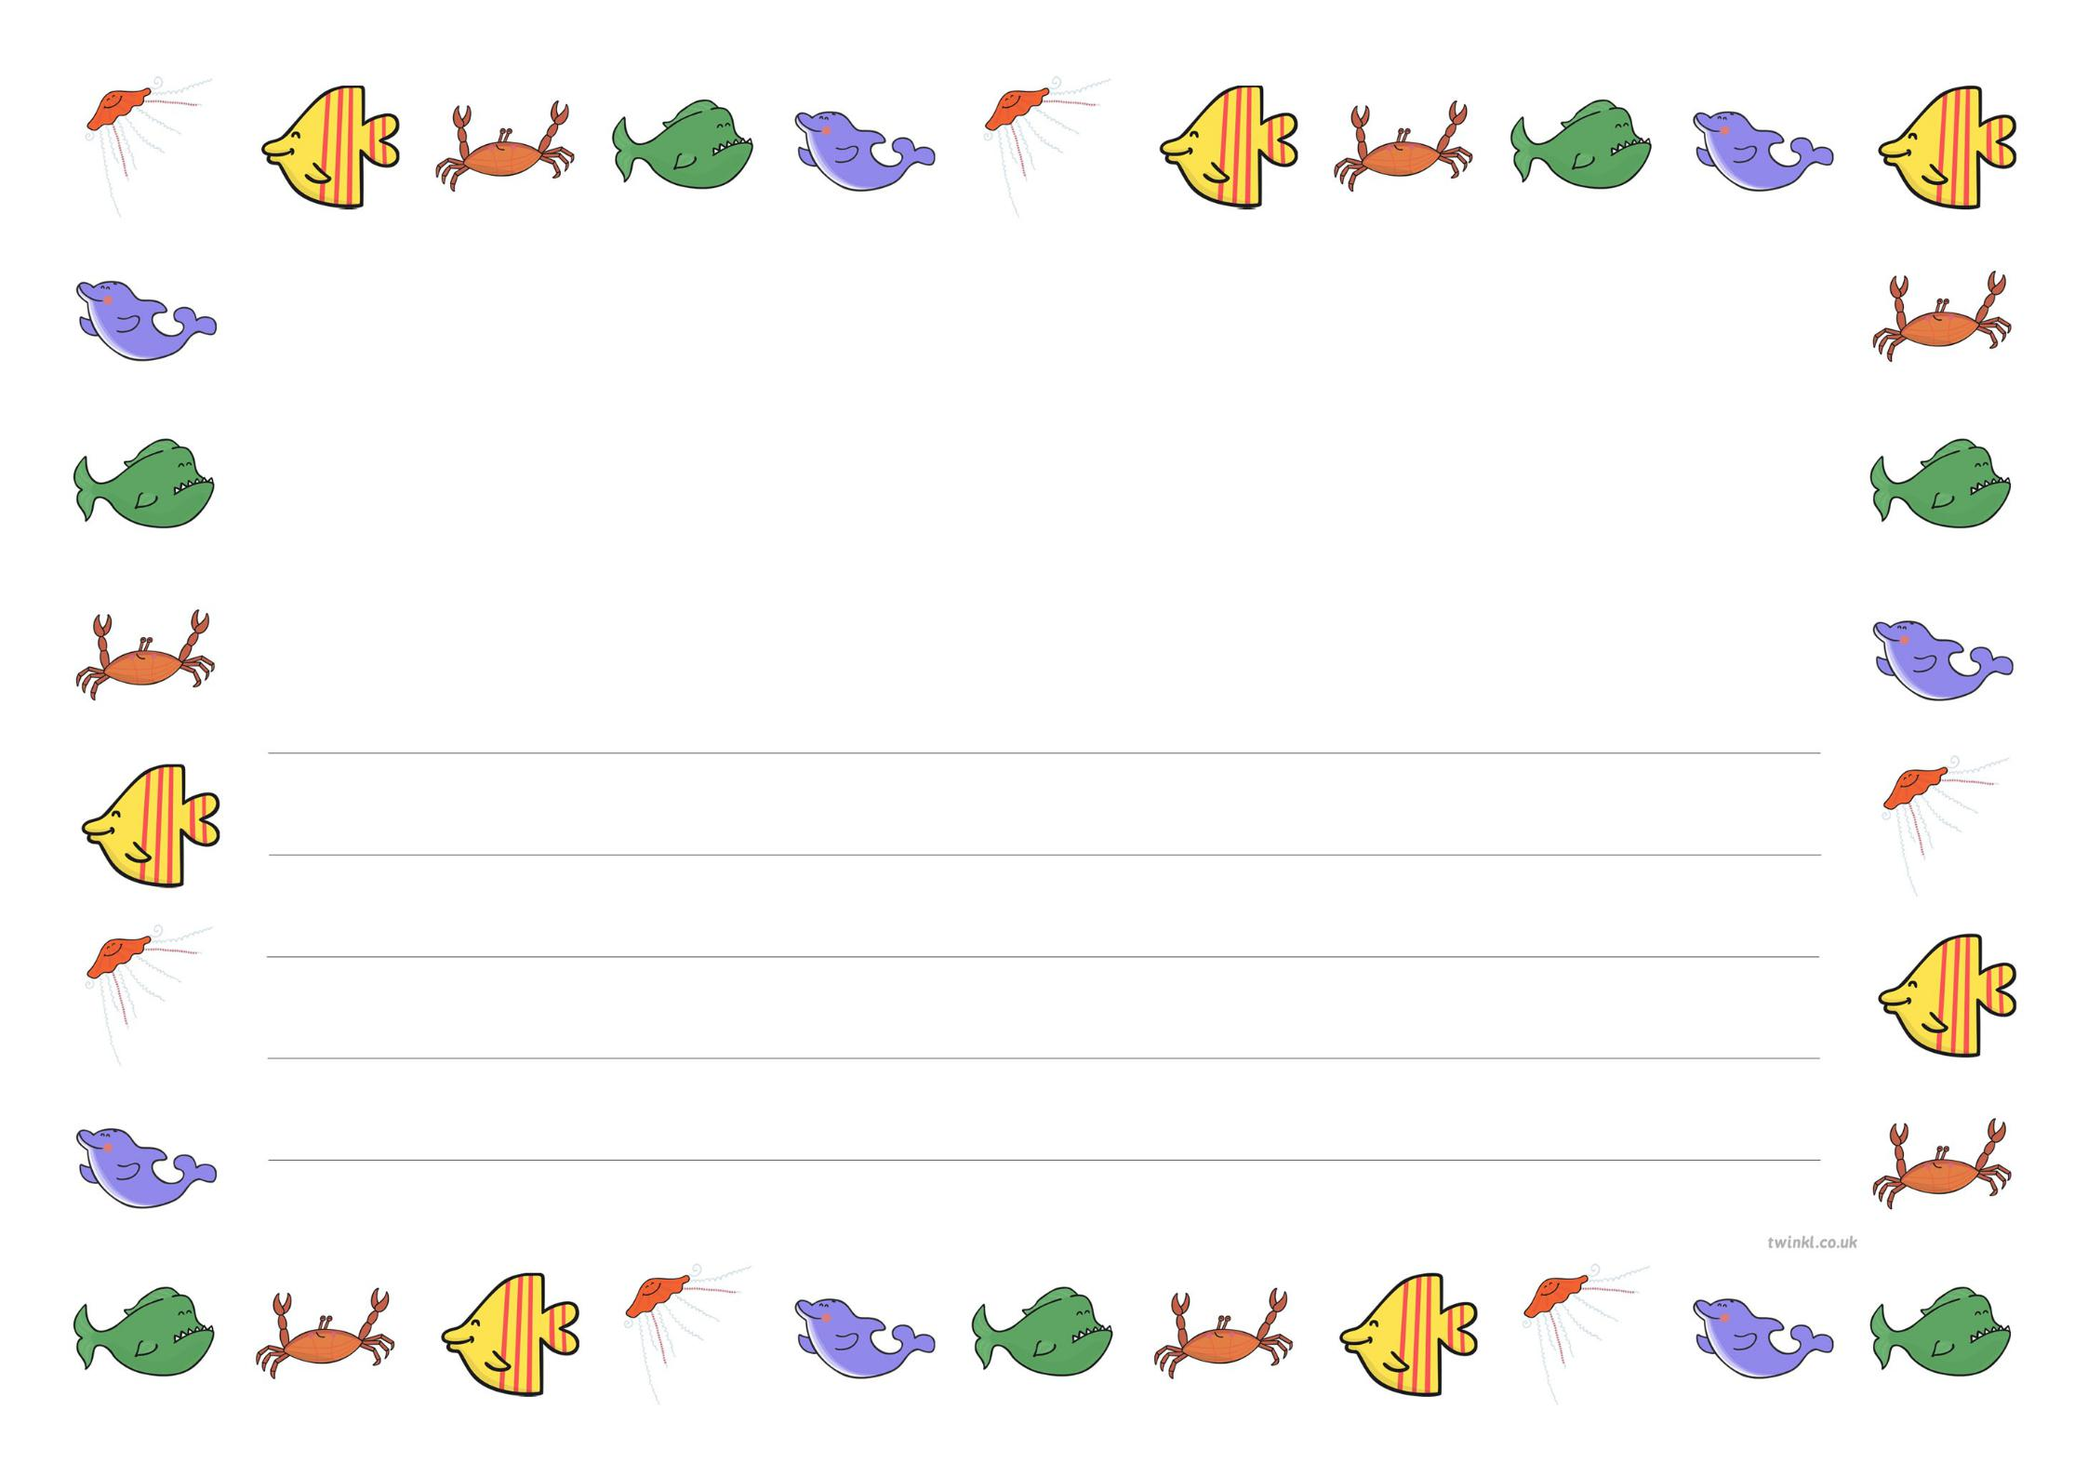
The ………. likes walking sideways
And I think the reason why,
Is to make himself look sneaky
And pretend that he’s a spy.

Is the missing word, crab or shark?
Write in the missing word and draw a picture or find a picture to cut out.
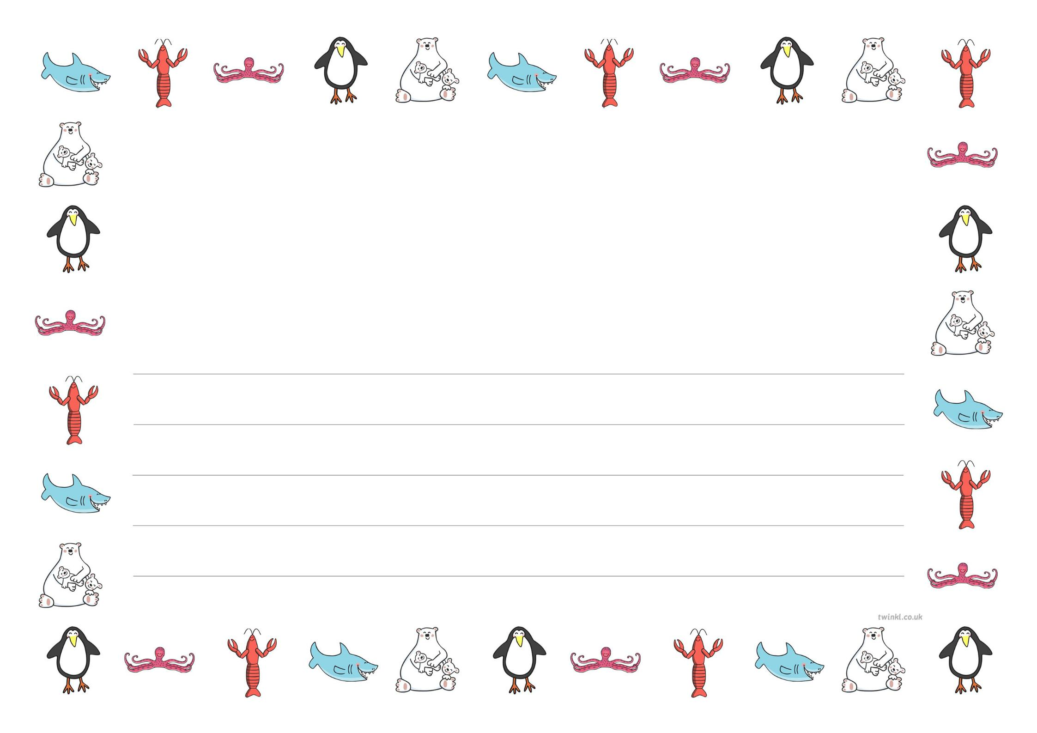

What sea creature is this poem about from the story?
-------------------
We waddle about on our icebergs,
Which makes our feet slither and slide,
And when we get close to the water,
We leap with a splosh off the side.

Write the answer in the space above and draw a picture. Is it a Penguin, or a Polar Bear?

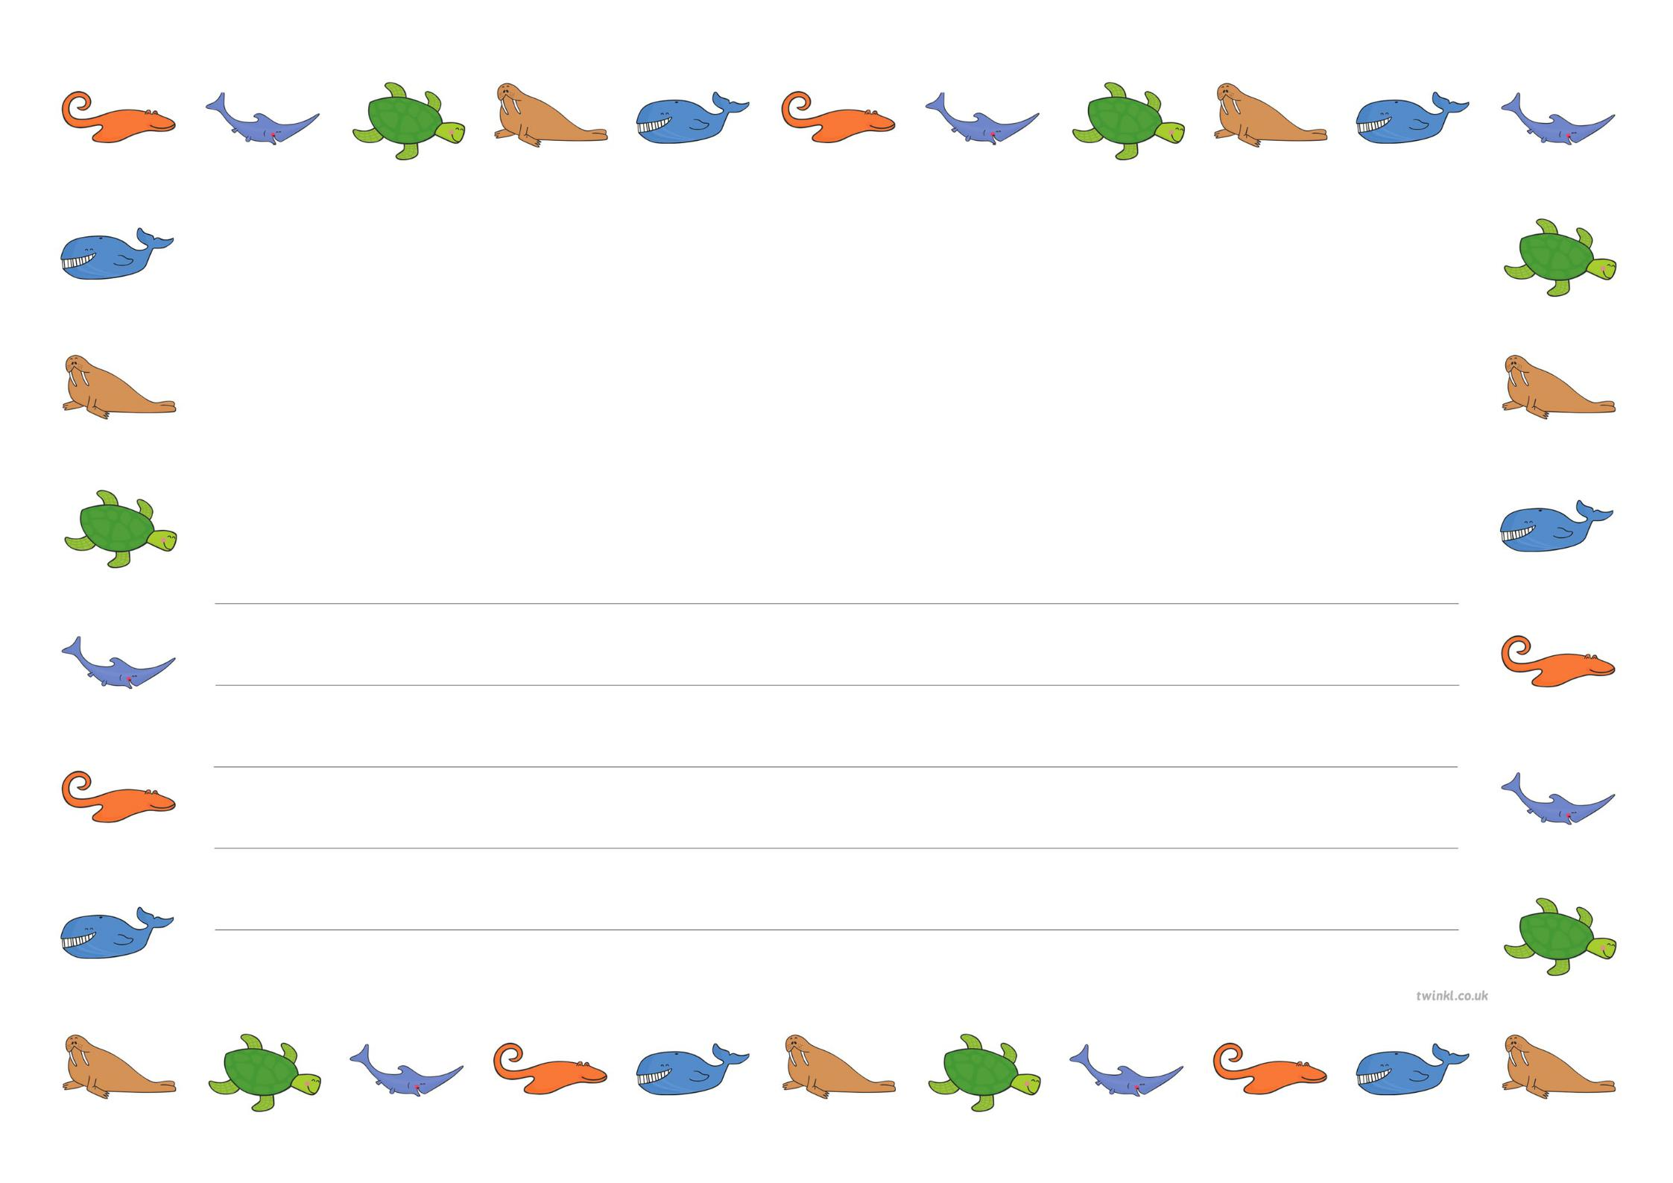

Can you guess what sea creature this is from the story?
I swim with a grin up to greet you,
See how my jaws open wide,
Why don’t you come a bit closer?
Please take a good luck inside.

Is it a Shark or a Jellyfish? Can you draw a picture of your sea creature in the space above?

