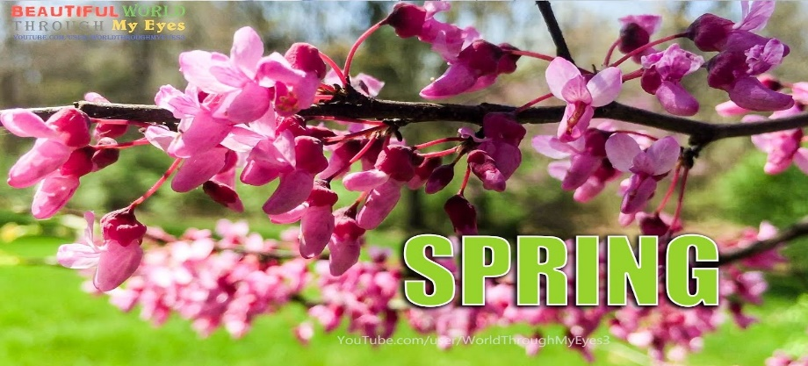

Find the right word and write it by the picture

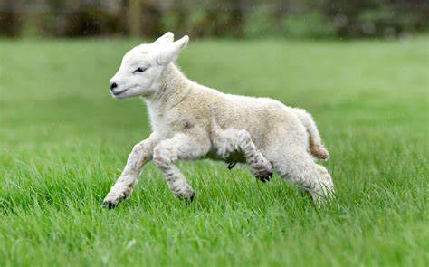
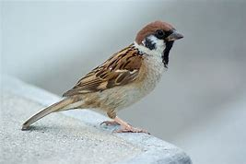
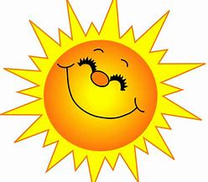
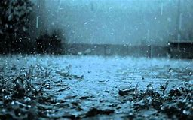
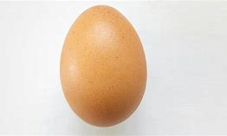
sun egg bird lamb rain

Write an acrostic spring poem where the first letter of each line spells out
SPRING

S _________________

P _________________

R _________________

I _________________

N _________________

G _________________

