Link Project Newsletter

Hello everyone!! We hope you’re all well and staying safe. Here goes then! Round two of our Newsletter. 😍 We hope you enjoy reading and looking at all our news! We can tell you have been very busy and having enormous amounts of fun! We absolutely love receiving your amazing photos and videos. Please keep sending what you can in, so we can share them with your friends. 💗💓😍
You will notice that we have changed the title of our Newsletter. From next week our friends over at the college will be able to access our page and see what you have all been up to. This will work both ways and I will be sharing with you the details to access their college page. I will send you an email with the log in details on separately very soon.
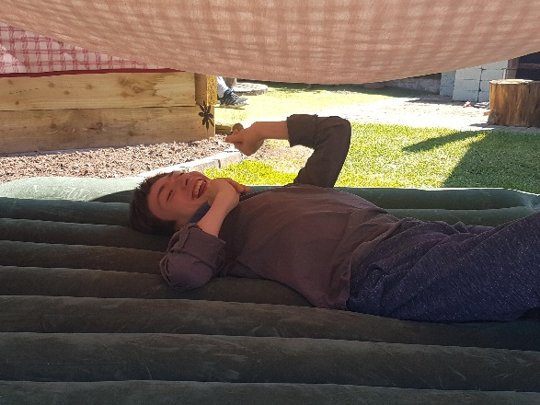
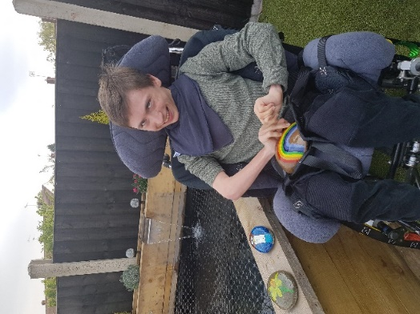

Mason
Fun times decorating stones at Mason’s house this week! This one’s for you NHS!!🌈 Loving your Rainbow Mason. Don’t forget to look out for us! We’ll be clapping👏 outside again 8.00p.m Thursday. After a hard day painting🎨 there’s nothing better than lounging outside in the sunshine on an airbed, with a good old cuppa!☕

Timothy

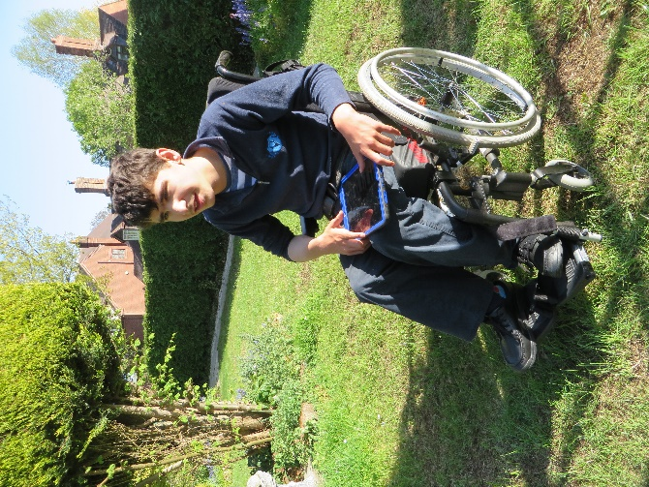
Timothy has been enjoying lots of time in the garden🌻🌳 weather🌞☔ permitting of course! He has been laughing, while his Grandad was using the strimmer. Timothy has also been tinkering with an old tractor! 🚜 We can’t wait to see the finished results!
Tim has also been to his fields on the farm. How are the lambs? We bet you are more than ready for your Nan’s delicious cooking🍰 after all your hard work!

We hope you have lots of spare batteries for all your gadgets Timothy! Keep playing and singing your favourite songs🎵🎤

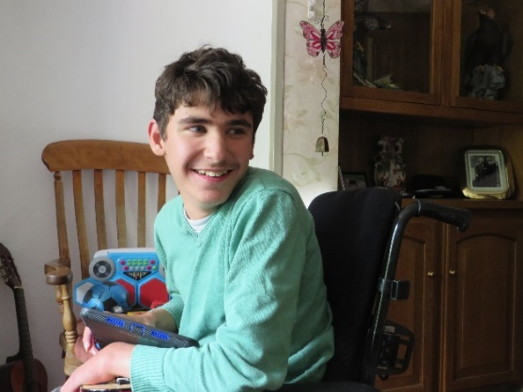

Kyle
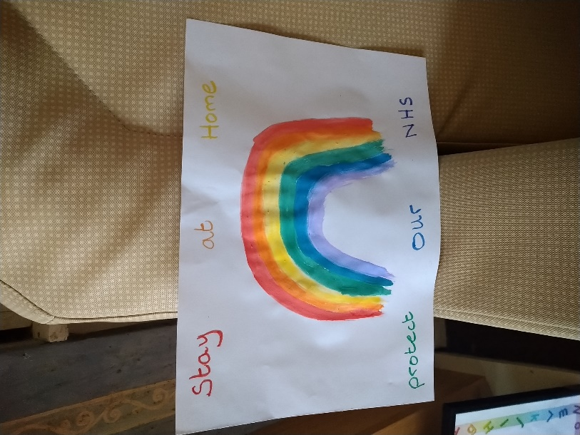
Kyle has been busy painting🎨 this week. He painted a bright, colourful Rainbow🌈 and matched the writing on his poster to the colours of the rainbow with a very important message to us all “Stay at home. Protect our NHS!”
The fun has continued in Kyle’s house throughout the week as he had a sensory disco in his room, showing his Mom all his cool dance moves.

Holly
Holly has been busy looking and listening to her “Noisy Animals” 🐴🐮🐷 book 📕 What was your favourite animal Holly? We are working on a new animal story which will be coming soon to the website, so keep a look out for it. You will be able to recognise all of the animal sounds.
Great bubble blowing Holly! We bet you had lots of fun with your sisters. How big were the bubbles? We love the way you are reaching up with your arms to hold the bubble holder. Keep up the good work!
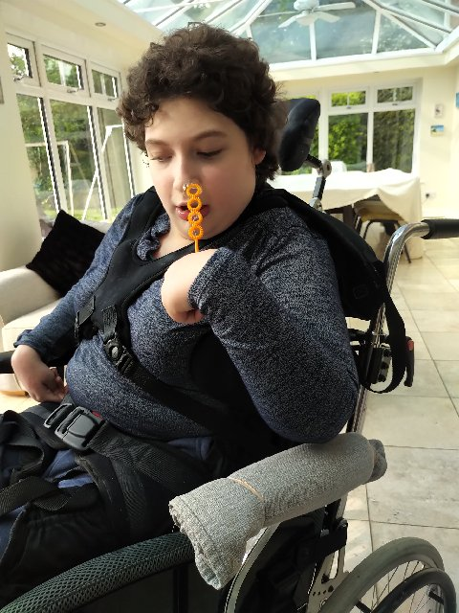
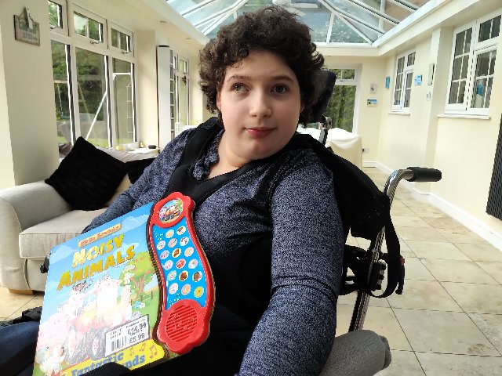

Megan
Megan has been enjoying the stories📗 on our school website this week and catching up with her friends news. From looking at your smile in this pic Meg, we think you have found something funny. It could have been when you knocked the water over in the garden that Dad had put there for you to explore. It’s good to see you have been exploring outside 🦋🌹We see you have been interested in your slinky! Don’t lose it in the garden, we know that Fern loves playing with a slinky too!
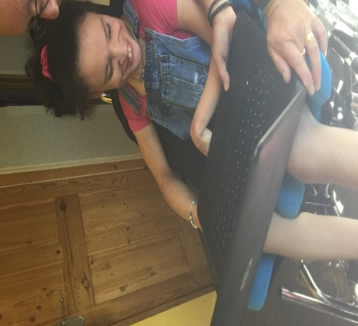
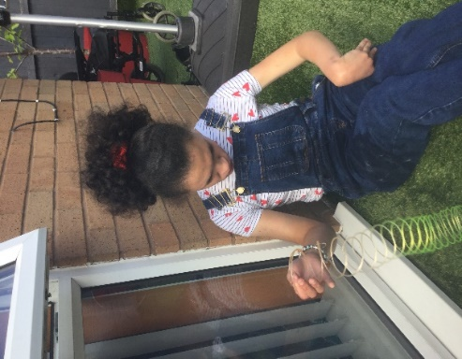
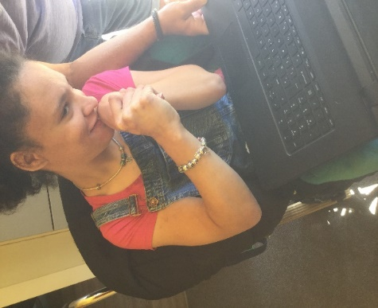
Jessica
Jessica has been very creative at home🏡. Just like Megan, Jess has been getting outside with nature in her garden. She has seen some birds🐦 butterflies🦋 bees🐝 and even a frog🐸 in her fish🐠 pond! Bet it felt really slimy? Jess has even grown some lettuce and radishes to put on her window ledge so she can watch them grow, yummy! Delicious salad to go with a Barbecue and all washed down with a lovely cool Pimm’s!
Just like Kyle, Jess has painted🎨 a rainbow🌈 for our wonderful NHS staff to put in her window and show support. We love how you’re holding your paintbrush. Keep being creative Jess and sending us your lovely pictures😍

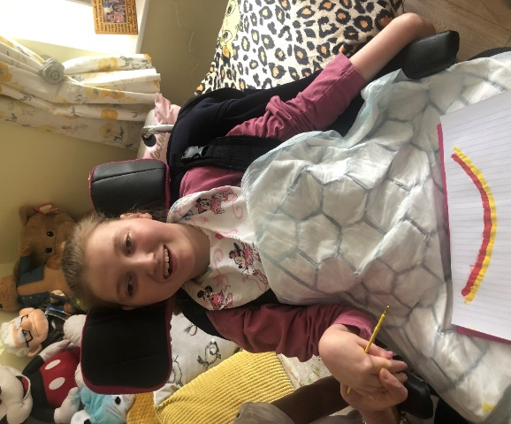
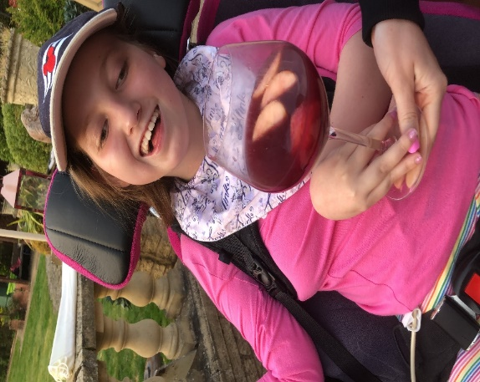
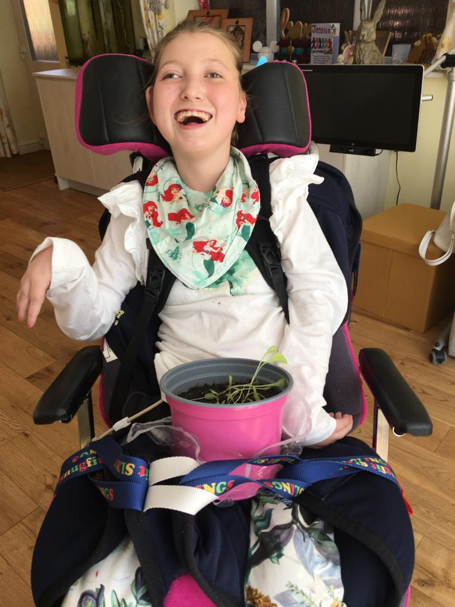
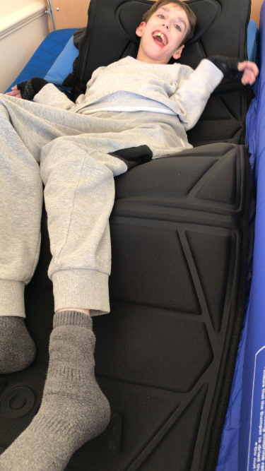
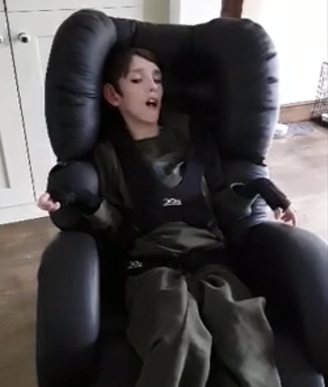
Jimmy
Hello to Jimmy! Jimmy has been very happy and relaxed at home and we can’t blame him, look at his amazing massage chair! We would all love to have one of those. Jimmy has also been listening to his new collection of Harry Potter books and chilling out listening to some of his favourite music🎧🎵 We are trying to guess what superhero movies you have been watching!📺🎬

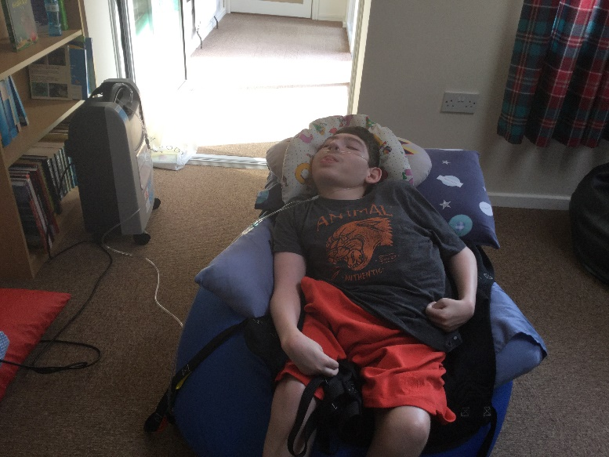
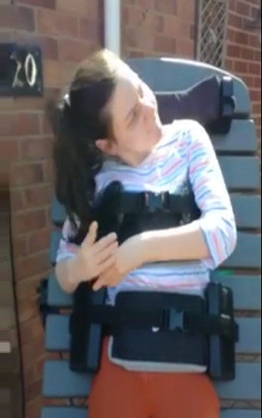
Thank you all for your wonderful photos and news! Please keep sending them in for us to share with your friends. There’s also lots of stories and activities to look and listen to on our school website.
Keep safe everyone.
Love from
14US team😘
Ange, Ria, Lisa, Kate, Hayley and Ren xxxx

Jack has continued to stay active at home and has been in the pool lots.
He really enjoyed the story Windows on the website this week. He especially liked looking and listening to what his friends were doing inside their houses.
Just like Jimmy, Jack loves listening to books and is a bit of a super hero fan himself.
Fern has been working hard in her stander again and making the most out of the nice weather at the same time.
Fern likes to sing outside and entertains anyone that can hear her. She has been very chatty to Ren on the phone during her weekly calls.
Fern likes to play Bingo with her Mom and Dad, we bet you are missing socialising with your Bingo community.
We will have to set up a class bingo game

