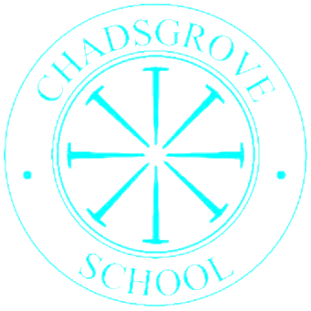

Chadsgrove Curriculum Cross Curricular Topics:

Navigators 3

|  |  |  |  |  |  |  |
| --- | --- | --- | --- | --- | --- | --- |
|  | **Autumn** | | **Spring** | | **Summer** | |
|  | ***Values*** | *Welcoming and Friendship* | *Fun and Independence* | | *Trust and Teamwork* | |
| **2025** | People | **2026** | Recycling | **2026** | Festivals  Food |
| **2026** | Victorian Britain | **2027** | Life Cycles of Animals & Plants | **2027** | The Seasons  Weather |
| **2027** | Digital photography | **2028** | Change | **2028** | Water |