Maths Home Learning
Beginning the 27th April

Please find some activities below to help you child improve their maths skills whilst at home.
Our topic for the next two weeks is recognising numbers, counting and making models (don’t worry if you don’t have any Lego at home, you can follow along with the other activities mentioned!).

Activities:
- Ordering numbers 1-10

This activity will involve creating a number line from 1-10 at home (See example below). Once complete, cut out the numbers individually and let your child order the numbers from 1-10 in the correct order. You may need to make an additional number line to help guide them.

1 | 2 | 3 | 4 | 5
6 | 7 | 8 | 9 | 10

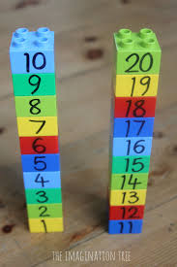
This activity will involve using the number line you have created in the previous activity. Stick the individual numbers on some Lego bricks and let your child build number towers. Don’t worry if you don’t have Lego blocks. You can recreate this activity with any stackable item (e.g. building blocks)

- Ordering numbers 1-10 : Cut and Stick (Lego activity)

- Number Bingo
Divide a piece of paper into 6 squares. Write a random number from 1-10 or higher in each square. Let your child have the piece of paper with the numbers on. Call out a number. If your child has the number on their sheet, get them to scribble the number out. Once all numbers have been scribbled out, shout BINGO. You can use a small whiteboard/chalkboard if you have one. Then you can rub the number off.

You can also modify this activity by showing your child a picture of the number you are calling out. This may be easier for the child to recognise the number and mark it off their sheet.
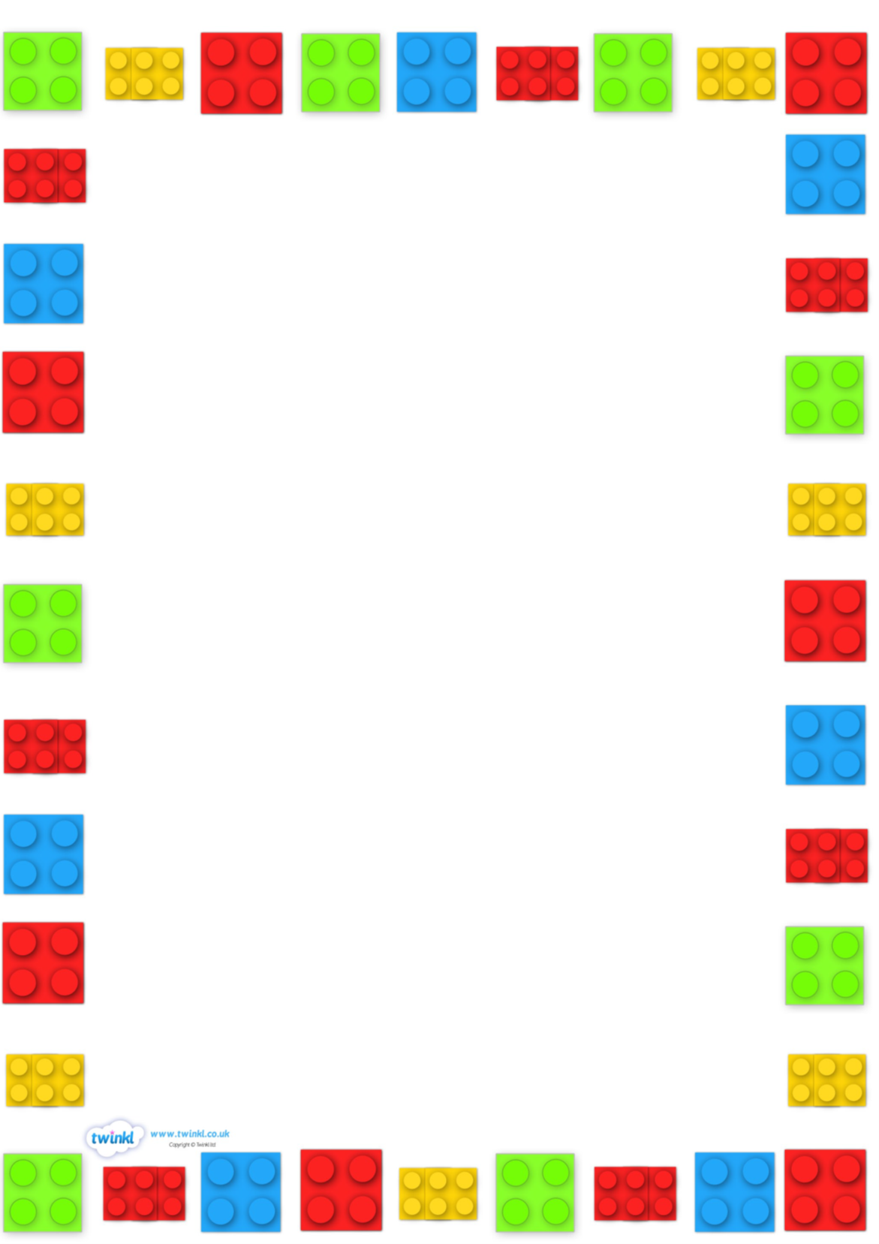
4. Make a model / picture

This activity will involve making a picture or model using a set number of Lego bricks. For example … ‘Make a model using 5 Lego Bricks’. If you do not have Lego bricks, you can get inventive! Try using sticks or stones from the garden, leaves, toy figurines etc. (The basis of this activity is using the correct number of items to design a model / picture).

5. Play Games that involve numbers and counting e.g. Dominoes / Board games

6. Try following a recipe together and try counting the number of ingredients you are using / measuring out.

7. Go on a shape hunt around the house or garden. Try and identify different shaped objects. You may even have a ‘Shape of the Week’, where you have to identify that shape throughout the week as many times as you can.

8. Use playdough (See Recipe on school website) to make numbers.

