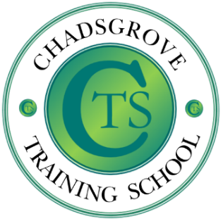

Teachers, Teaching Assistants, SLT, Parents / Carers

**Course content:**

* During this session participants will be supported to understand a child’s life journey and develop their ability to recognise attachment and trauma difficulties.
* Participants will learn strategies to help and support children with these difficulties and identify how a whole school approach is fundamental to supporting children to succeed.

An Introduction to Attachment Difficulties and Developing a Whole School Approach

This session will provide an introduction to attachment difficulties and developmental trauma and identify implications for learning and behaviour.

Most children enjoy life and are successful in school and in their relationships. However, a significant minority can struggle from an early age and encounter increasing difficulties as they develop through adolescence.

**16th October 2024, 4pm to 5.30pm  
Online Course**

**£45** per delegate

Course led by Iain Chatwin  
Iain draws upon over 35 years’ experience of working with children and young adults with ADHD and autism spectrum disorders, ranging from those with complex learning difficulties and disabilities to those studying for GCSE examinations. He has worked in schools, residential settings, and has been leading training for professionals and parents for more than 20 years, alongside consultancy work, university lecturing, writing journal articles, book chapters and contributing to online materials.

***This training will be delivered online.***

*Please complete and return the booking form overleaf or contact the school*

Email: courses@chadsgrove.worcs.sch.uk

Tel: 01527 871511

S.E.N.D.

**Chadsgrove Training School**

**Professional Development**



Chadsgrove Training School

|  |  |  |  |  |  |
| --- | --- | --- | --- | --- | --- |
| Course Title: **An Introduction to Attachment Difficulties (Online)** Training Date: **16th Oct 2024** (Course led by: Iain Chatwin)  **Number of Places Required** (@£45 each): | |  | | | |
| Attendee(s) Name & Email Address | | | | | |
| The information you provide in this form will be used solely for processing your course booking. If you wish us to retain your email address to contact you about future CTSA professional development opportunities please tick this box | | |  |  |  |
|  |
|  |
| Occupation: | | | | | |
| Special Requirements:  (e.g. dietary, access, etc.) | | | | | |
| Organisation name: | | | | | |
| Postal Address for Correspondence: | | | | | |
| Invoicing Address (*if different to Postal Address*):  Email:  Telephone Number: | | | | | |
| Total Cost:  *(Please make cheques payable to Worcestershire County Council)* | | | | | |
| Cost Centre for Internal Transfer for **Worcestershire Schools**. Please complete **both** sections below.  Project Code: Cost Centre: | | | | | |
| Authorised Signature (Headteacher): | Name: | | | | |
| *We regret that we cannot accept typed signatures. Digital signatures or scanned electronic copies are suitable.* | | | | | |

*Please return to:*

Chadsgrove Training School, Meadow Road, Catshill, Bromsgrove, Worcestershire, B61 0JL

Tel: 01527 871511 Email: courses@chadsgrove.worcs.sch.uk

**In the event of unforeseen circumstances we reserve the right to cancel or alter parts of the programme.**