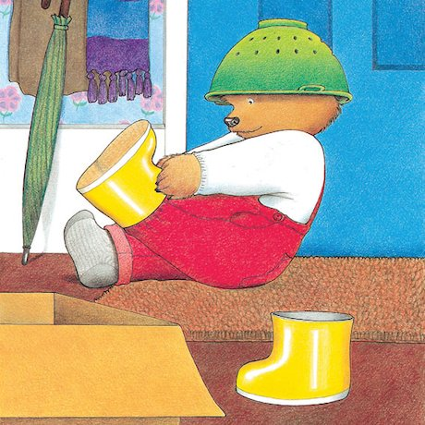
Whatever Next! By Jill Murphy
4LS have chosen this story, as not only do we really enjoy this story ourselves, but we feel there are lots of sensory opportunities within the story e.g. smells, textures to feel, tastes (where appropriate) sounds to hear, and things to look at for you to share with your child at home. When we return to school, we are hoping to continue to share this story as a class. With repetition and familiarity of the story, your child will have opportunities to develop their Communication & Thinking Skills, such as: anticipation, requesting ‘more’, tracking and developing preferences towards the exciting sensory experiences within the story.
Please find below some sensory activities to support the telling of this story. We would recommend putting these together before telling the story, as the video refers to these resources at the bottom of the pages. Hopefully, you should find these simple and easy to make but don’t worry if you need to adapt these to suit your child’s needs – we often do this at school too!
This is by no means a mandatory task/homework; we absolutely appreciate how busy you all are in this tricky period. These are purely suggested activities you can do, if you feel you would like to do some home learning with your child.
If you have any difficulties/questions/want to share some photographs of you and your child enjoying these activities, please drop me an email on my school email address:
rmccann@chadsgrove.worcs.sch.uk
Finally, thank you so much for everything you are doing with your child at home. We hope you enjoy sharing this sensory story and you can share some magical moments together!

Best wishes,
Rebecca & the 4LS team

Resources in the story:
. Torch
. Water (spray bottle or drip using a sponge/cloth)
. Colander/plastic bowl
. Cardboard box/blanket
. Shoes/boots/slippers to put on their feet
. Teddy/soft stuffed toy
. Crinkly empty crisp packet
. Cocoa powder (a little bit to put on your finger)
. Owl – feathery object e.g. feather duster
. Sensory Picnic Tray
. Sensory Space bottle
. Sensory ‘Moon Sand’

