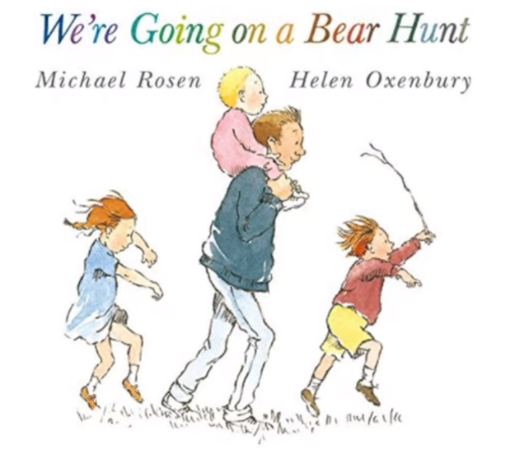

https://www.youtube.com/watch?v=0x1L3WeyTDA

A message from Billy Bragg:
Due to the lockdown, we were unable to be with our granddaughter on her fourth birthday this week. She likes to wander into my office when she comes over and strum my guitar on its stand. That’s usually a sign that she’d like me to play a song for her.
One of the books that we have for her to read when she’s here is Michael Rosen’s wonderful story ‘We’re Going on a Bear Hunt’, illustrated by Helen Oxenbury.
A year or so ago, I set the text to the tune of an old folk song we used to sing at primary school called ‘The Keel Row’. It proved so popular that she asks to hear it whenever she comes to visit.
Unable to see her this birthday, I decided to record the song and send it to her instead.

Perhaps you know someone who might like to hear it too.

www.billybragg.co.uk

