

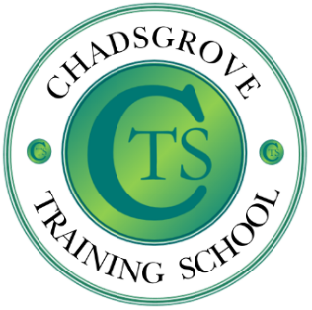

Participants will gain:
- An understanding of how to implement Lego®-based therapy.

- Awareness of the evidence to support its effectiveness in developing social skills.

- Guidance on effective monitoring and recording of sessions and individual attainment.

17th November 2026 9.30am to 12.00pm
Chadsgrove School
£75 per delegate
Lego® is a highly structured and systematic construction toy, meaning that children on the autism spectrum are likely to be motivated by tasks involving its use.
This workshop will explore strategies that are indicated to support effective use of Lego®-based activities and identify how to set up and implement Lego®-based therapy for children on the autism spectrum and those with related social communication difficulties and anxiety conditions.
The therapy uses Lego® construction to encourage verbal and non-verbal communication, and social development such as joint attention, sharing, turn-taking and following social rules.
Lego® Therapy

Course led by Iain Chatwin
Iain draws upon over 35 years’ experience of working with children and young adults with ADHD and autism spectrum disorders, ranging from those with complex learning difficulties and disabilities to those studying for GCSE examinations. He has worked in schools, residential settings, and has been leading training for professionals and parents for more than 20 years, alongside consultancy work, university lecturing, writing journal articles, book chapters and contributing to online materials.
This training will be face-to-face at Chadsgrove School, Meadow Road, Catshill, Bromsgrove, Worcestershire B61 0JL

Please complete and return the booking form overleaf or contact the school
Email: courses@chadsgrove.worcs.sch.uk
Tel: 01527 871511
S.E.N.D.
Chadsgrove Training School
Professional Development

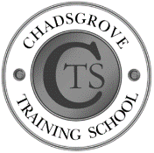
Chadsgrove Training School

Course Title: Lego® Therapy Training Date: 17th Nov 26
(Course led by: Iain Chatwin)
Number of Places Required (@£75 each):
Attendee(s) Name & Email Address

The information you provide in this form will be used solely for processing your course booking. If you wish us to retain your email address to contact you about future CTSA professional development opportunities please tick this box
Occupation:
Special Requirements:
(e.g. dietary, access, etc.)
Organisation name:


Postal Address for Correspondence:
Invoicing Address (if different to Postal Address):

Email:
Telephone Number:
Total Cost:

(Please make cheques payable to Worcestershire County Council)
Cost Centre for Internal Transfer for Worcestershire Schools. Please complete both sections below.

Project Code: Cost Centre:
Authorised Signature (Headteacher): | Name:
We regret that we cannot accept typed signatures. Digital signatures or scanned electronic copies are suitable.
Please return to:
Chadsgrove Training School, Meadow Road, Catshill, Bromsgrove, Worcestershire, B61 0JL

Tel: 01527 871511 Email: courses@chadsgrove.worcs.sch.uk
In the event of unforeseen circumstances, we reserve the right to cancel or alter parts of the programme.

