

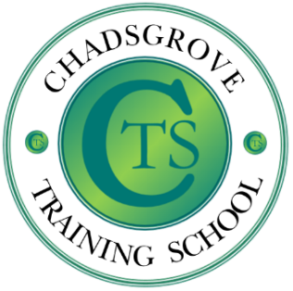

Chadsgrove Training School

Iain draws upon over 35 years experience of working with children and young adults with autism spectrum disorders, ranging from those with complex learning difficulties and disabilities to those studying for GCSE examinations. He has worked in schools, residential settings, and has been leading training for professionals and parents for more than 15 years, alongside consultancy work, university lecturing and contributing to texts and online materials.

The autism spectrum encompasses complex neurobiological differences, and nearly three-quarters of children with autism spectrum disorder (ASD) also have an additional diagnosis, whilst others are identified as displaying the characteristics of sub profiles such as Pathological Demand Avoidance (PDA). This session will explore the interaction of dual diagnoses and the nature of Pathological Demand Avoidance, focusing on their impact on communication, relationships, education, and behaviour, and how to enable pupils to take an active part in their education through identifying the means to effective support

Course led by Iain Chatwin

Tuesday 17th March 2026 Online 4.00p.m.– 5.30p.m.

£45 per delegate
The Autism Spectrum:
Dual Diagnosis and PDA
Mainstream & Special
Please complete and return the booking form overleaf or contact the school
This session will be hosted on Zoom. Full instructions for joining will be sent to delegates.
Email: courses@chadsgrove.worcs.sch.uk
Tel: 01527 871511
Online Professional Development

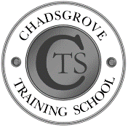
Chadsgrove Training School

The Autism Spectrum: Dual Diagnosis & PDA
17th March 2026 Number of places at £45 each:
Attendee(s) Name & Email Address

The information you provide in this form will be used solely for processing your course booking. If you wish us to retain your email address to contact you about future CTSA professional development opportunities please tick this box
Occupation:
Special Requirements:
(e.g. dietary, access, etc)
Organisation name:
Postal Address for Correspondence:
Invoicing Address (if different to Postal Address):

Email:
Telephone Number:
Total Cost:
(Please make cheques payable to Worcestershire County Council)
Cost Centre for Internal Transfer for Worcestershire Schools. Please complete both sections below.

Project Code: Cost Centre:
Authorised Signature (Headteacher): | Name:
We regret that we cannot accept typed signatures. Digital signatures or scanned electronic copies are suitable.
In the event of unforeseen circumstances we reserve the right to cancel or alter parts of the programme.
Please return to:
Chadsgrove Teaching School, Meadow Road, Catshill, Bromsgrove, Worcestershire, B61 0JL

Tel: 01527 871511 Email: courses@chadsgrove.worcs.sch.uk

