People who help us – Postman
Have a look through and choose which activities your child would enjoy
- Make someone’s day and make a card for a friend or family member and, if you are able, go for a walk to post the card in the letterbox or ask a friend to post it for you.
- Make your own post box from an old box and have fun role playing being a Postman.
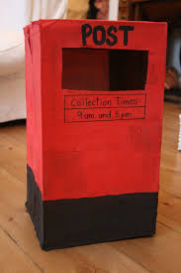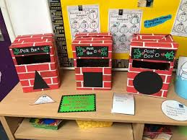
- Make your own sorting office and sort your letters to the family. This could also be a colour or number matching activity by writing numbers on the wallets or matching the different coloured card.
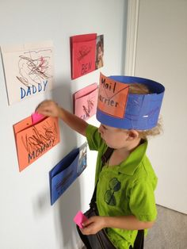
- Use a potato or something similar to cut into a square. Dip into paint and stamp all your pretend letters. Sing the song, delivering the letters all round the house to the right people!
Lots of letters in the postman's sack
He knocks on the door with a rat a tat tat
He posts a letter through (name) door
The letter falls down on the floor
- Listen to the Postman Pat theme tune together.
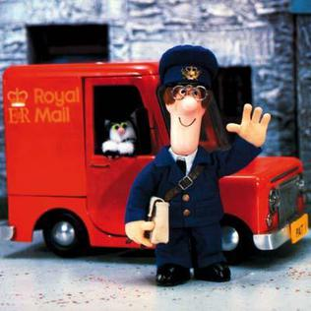
- Watch the video of Miss Harris reading Postman Bear.
- Have a go at making Postman Pat’s van out of cake! You could use a bought cake if baking is difficult. Cut it into the shape of his van and cover with red coloured icing. Make the windows and wheels by cutting the shapes from readymade white icing. Enjoy getting very messy along the way!
Have fun!

