Butterfly sensory bags
From teachpreschool.org
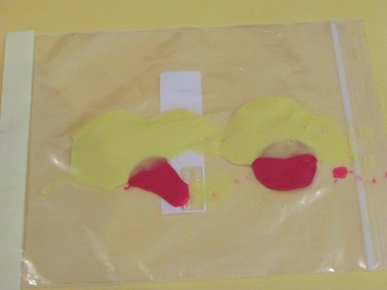

Start by putting some drops of paint (or food colouring) into a plastic zip lock bag.
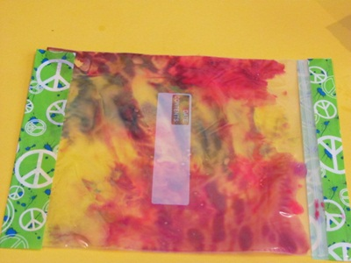

Mix the paint around inside the bag. You could tape the ends of the bag with some coloured sticky tape.
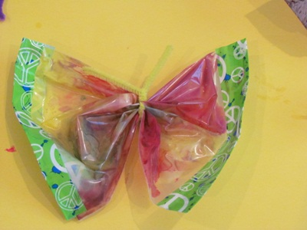

Tie a pipe cleaner or wire tag in the middle to make the antennae.

Now you have created some butterflies!

