Sports Studies Online Learning Lesson 2
Tuesday 31st March
Legacy of an International Sports Event
Name_______________________

Legacy means the long-term effects and positive impact of hosting the Games for a Country, its people and provision of sporting activities

- Follow this link to watch a 4 minute video
https://www.olympic.org/olympic-legacy/london-2012

- Expected Long-term benefits- Read the information in the boxes
Draw a line linking the statement with the picture
Organised sports development |  | 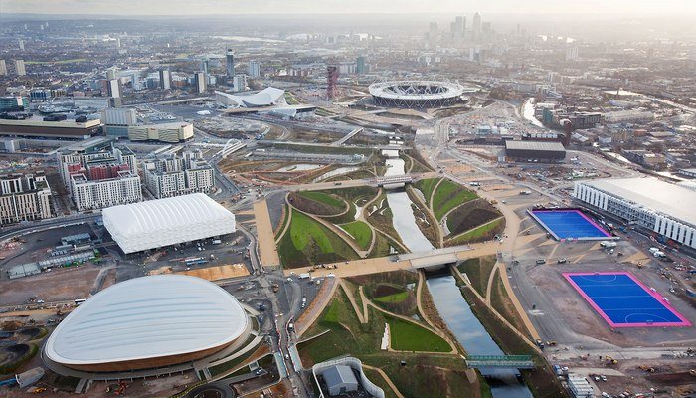  Improving derelict land
Urban development |  | Sport England will give GBP 493 million to grassroots sport between 2013 and 2017  The Aquatics Centre will be open to clubs, schools and the general public, as well as elite athletes.  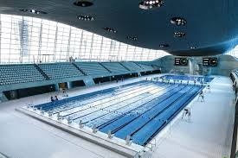
Economic value |  | 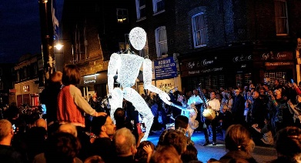  Arts event that attract tourists
Improvements to the environment |  | Jobs created during the building of the facilities.  The skills learnt allowed the builder to get jobs after the games.
Cultural and creative development |  | 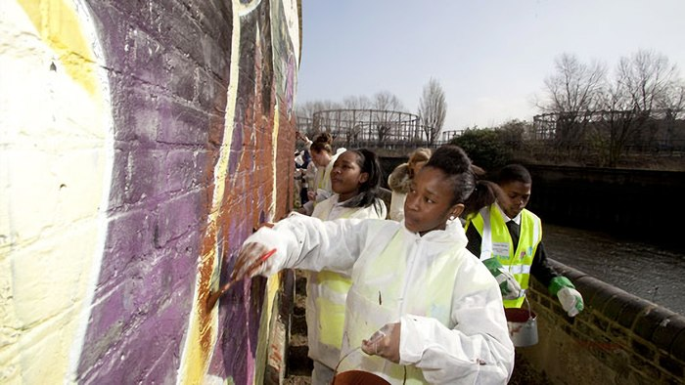  Inspiring young people to improve their environment
- Social Legacy of the Olympic Games
Complete the table of the different Social Legacys
Health and wellbeing benefits from physical activity | Circle the correct name for a tool that helps families keep healthy and active  Change for Life  Or  Life for Change
Olympic Values used in schools and sports | List 5 of the 7 sporting values  1  2  3  4  5
Inclusive opportunities for minorities, people with disabilities and LGBT | Give an example of a club or activity in your area.

- Page 30 of the etext book
List the 8 benefits of hosting the Olympics (in italics)

1.____________________________________

2.____________________________________

3.____________________________________

4.____________________________________

5.____________________________________

6.____________________________________

7._____________________________________

8._____________________________________

Answer the following exam questions using what you have learnt today and the last lesson in school using your red exercise book

(4)

