Comparing weights |  | SPRING Comparison & Measures:
Play Activity 1: Can comparison
Aims:  To compare the weights of more than 2 items.  To order items by weight. | You will need: four items of different weights  Words, heavy, heavier, heaviest, light, lighter, lightest (see separate sheet)
Activity:  Give your child items to hold and use the words ‘heavy’ and ‘light’ when talking about them. | Example of items:  Household items, tins or toys, children can pick them up hold them on their lap to feel the difference in weight.
What to do:  - Put out four items of different weights, e.g. book, bag sugar, toy, shoe  - Ask questions, e.g. Which is heaviest? Which is lightest? Could we arrange or order them in some way?  - Children, then put them in order by comparing two at a time.  - Can they find anything else around the home that is heavier, lighter than the book/toy | 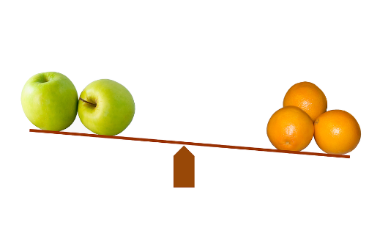
Talking points  - Which do you think is the heaviest/lightest?  - Do you think this one will be heavier/lighter than that one? Why do you think that?  - How will you test out your idea? Are you surprised? Why or why not?  - Could we arrange or order them in some way? | Evidence of learning:  Listen to children talking/signing/using communicate in print symbols. Do they use the words lighter/est and heavier/est?  Observe children. Can they explain Why have you put that one there?
Outcomes: I can say which is the lightest and which is the heaviest.

