Moon-Sand Recipe
This ‘sand’ crumbles like sand but can be moulded together like playdough! It’s soft to feel and fun to explore!

You will need:

- 130g flour
- 170ml cup vegetable oil
- (optional) Essential oil e.g. lavender
- (optional) Glitter
- (optional) a few drops of food colouring

Instructions:
- Scoop and pour the flour into the centre of a large tub.
- Create a crater in the middle of the flour.
- Pour the oil into the crater.
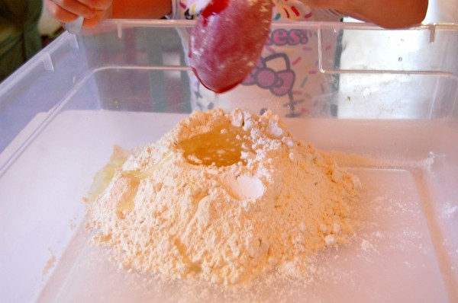
- Gently mix it all together (add food colouring, glitter and Essential Oil here if you want to).
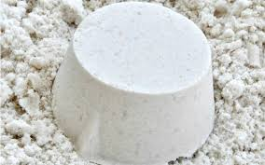
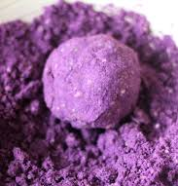
- Store in an airtight container to use again and again!

