People who help us – Dentist
Take a look through these suggested learning activities and choose what you feel your child would enjoy.
- Make marks on paper by dipping old toothbrushes in paint.
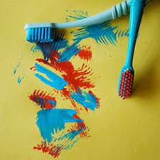
- Make lots of smiles with cut apple, marshmallows and peanut butter to glue them
together!
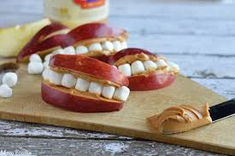
- Experience sensory play by squeezing out the toothpaste from the tube and exploring the texture and smell using fingers and toothbrushes.
- Collect together your child’s soft toys / dolls and pretend to brush their teeth with your child.
- Watch and listen to the song about going to the dentist together.
- Pretend to brush your teeth while listening to Mr Tumble’s song all about brushing our teeth.
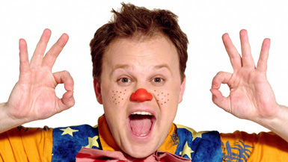
- Practice fine motor skills by showing your child how they can push the pretend teeth (small bottle tops or similar) into the playdough mouth, and then try to pull them out again!
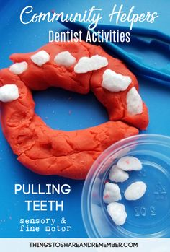 Have fun!

