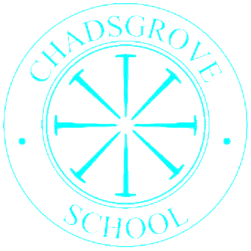

Chadsgrove Curriculum Cross Curricular Topics:

Navigators Curriculum Pathway:

Navigators 1

|  |  |  |  |  |  |  |
| --- | --- | --- | --- | --- | --- | --- |
|  | **Autumn** | | **Spring** | | **Summer** | |
|  | ***Values*** | *Welcoming and Friendship* | *Fun and Independence* | | *Trust and Teamwork* | |
| **2025** | People and Places | **2026** | Amazing Animals | **2026** | Out at Sea |
| **2026** | All About Me | **2027** | Let’s Build | **2027** | Out and About |
| **2027** | Wonderful World | **2028** | Perfect Plants | **2028** | Journeys |