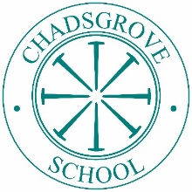

**Chadsgrove School**

Meadow Road, Catshill, Bromsgrove, Worcs B61 0JL

Head of School: **Bec Gayden**

**ADVERT**

**TEACHER**

**FIXED TERM MATERNITY COVER FOR 9 MONTHS**

**Required for January 2026**

Chadsgrove is a day special school for pupils aged 2-19, whose special educational needs arise from their physical difficulties and/or complex medical needs. In addition, a significant number of our pupils have profound and multiple learning difficulties, whilst others have sensory impairments and/or communication difficulties.

We are looking for an outstanding teacher, with experience of teaching children and/or young adults with special educational needs. You must have excellent written and verbal communication skills, and be able to deliver exciting and engaging activities, lead the class, and work effectively with our Teaching Assistants and wider school team.

You should have the skills and understanding of a range of teaching and learning strategies to make a positive impact on the children’s progress.

Further details and an application form are available from the school at the above address, by email or downloading from our website.

Closing Date: **Friday 17th October 2025**

Interviews: **Wednesday 22nd October 2025**

Chadsgrove School is committed to safeguarding and promoting the welfare of children and young people and expects all staff and volunteers to share this commitment. Following the procedures recommended to safeguard children, we will be taking up references before your interview. Please let your referees know to expect a reference request once you are notified if you are being interviewed (if you have indicated that we may contact them). The successful applicants will be required to undertake an Enhanced DBS check.