**CCN Assessment – School Checklist**

Name of Pupil:

Name of School:

Date form completed:

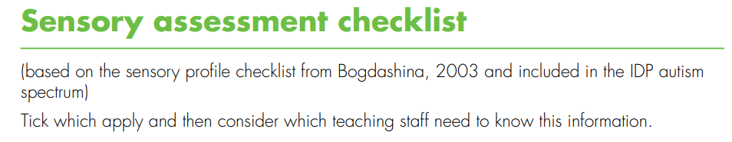

Please complete this sensory checklist for the pupil named above.

|  |  |  |  |  |
| --- | --- | --- | --- | --- |
| Number | Item | Yes | No | Don’t Know |
| 1 | Resists changes to familiar routines |  |  |  |
| 2 | Does not recognise familiar people in unfamiliar clothes |  |  |  |
| 3 | Dislikes bright lights |  |  |  |
| 4 | Dislikes fluorescent lights |  |  |  |
| 5 | Is frightened by flashes of light |  |  |  |
| 6 | Puts hands over eyes or closes eyes in bright light |  |  |  |
| 7 | Is attracted to lights |  |  |  |
| 8 | Is fascinated by shiny objects and bright colours |  |  |  |
| 9 | Touches the walls of rooms |  |  |  |
| 10 | Enjoys certain patterns (e.g. brickwork, stripes) |  |  |  |
| 11 | Gets lost easily |  |  |  |
| 12 | Has a fear of heights, lifts, escalators |  |  |  |
| 13 | Has difficulty catching balls |  |  |  |
| 14 | Is startled when approached by others |  |  |  |

|  |  |  |  |  |
| --- | --- | --- | --- | --- |
| Number | Item | Yes | No | Don’t Know |
| 15 | Smells, licks, taps objects and people |  |  |  |
| 16 | Appears not to see certain colours |  |  |  |
| 17 | Uses peripheral vision when doing a task |  |  |  |
| 18 | Find it easier to listen when not looking at person |  |  |  |
| 19 | Remembers routes and places extremely well |  |  |  |
| 20 | Can memorise large amounts of information on certain topics |  |  |  |
| 21 | Finds crowded areas very difficult |  |  |  |
| 22 | Prefers to sit at back of group or front of group |  |  |  |
| 23 | Covers ears when hears certain sounds |  |  |  |
| 24 | Can hear sounds which others do not hear |  |  |  |
| 25 | Is very distressed by certain sounds |  |  |  |
| 26 | Bangs objects and doors |  |  |  |
| 27 | Is attracted by sounds and noises |  |  |  |
| 28 | Does not like shaking hands or being hugged |  |  |  |
| 29 | Likes a hug if chosen to do this |  |  |  |
| 30 | Only seems to hear the first words of a sentence |  |  |  |
| 31 | Repeats exactly what others have said |  |  |  |
| 32 | Very good auditory memory for songs and rhymes |  |  |  |
| 33 | Dislikes the feel of certain fabrics and substances |  |  |  |
| 34 | Seems unaware of pain and temperature |  |  |  |
| 35 | Dislikes certain foods and drinks |  |  |  |

|  |  |  |  |  |
| --- | --- | --- | --- | --- |
| 36 | Seeks pressure by crawling under heavy objects |  |  |  |
| 37 | Hugs very tightly |  |  |  |
| 38 | Enjoys feeling certain materials |  |  |  |
| 39 | Dislikes certain everyday smells |  |  |  |
| 40 | Eats materials which are not edible |  |  |  |
| 41 | Likes to have food presented in a certain way on the plate |  |  |  |
| 42 | Dislikes crunchy or chewy food |  |  |  |
| 43 | Quite clumsy and bumps into objects and people |  |  |  |
| 44 | Fines fine motor movements hard |  |  |  |
| 45 | Has difficulty running and climbing |  |  |  |
| 46 | Finds it hard to ride a bike |  |  |  |
| 47 | Does not seem to know where their body is in space |  |  |  |
| 48 | Has poor balance |  |  |  |
| 49 | Afraid of everyday movement activities such as swings, slides, trampoline |  |  |  |
| 50 | Has extremely good balance |  |  |  |