6LS Staff News
Hi 6LS, we were thinking how very much we miss our chats about what we have been doing, making or eating!
So, we have put together a little newsletter to let you know what we have been up to!
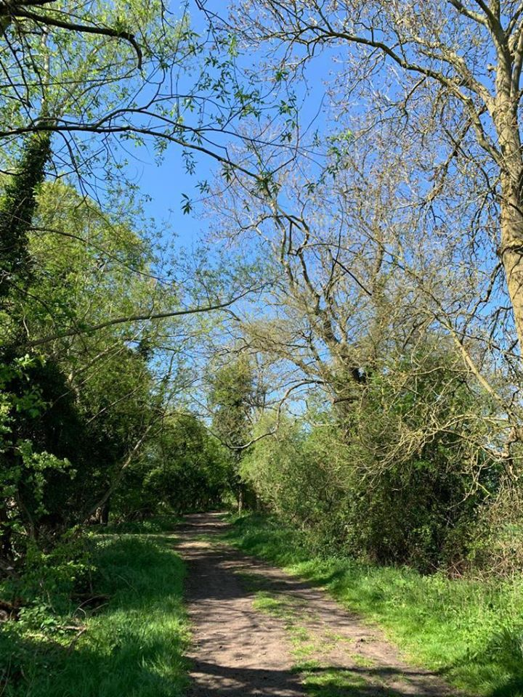
Jackie B.....has been taking her daily exercise close to where she lives, near Grafton Manor. This is a photo from one of those walks, aren’t we lucky to have such beautiful countryside to look at and use?
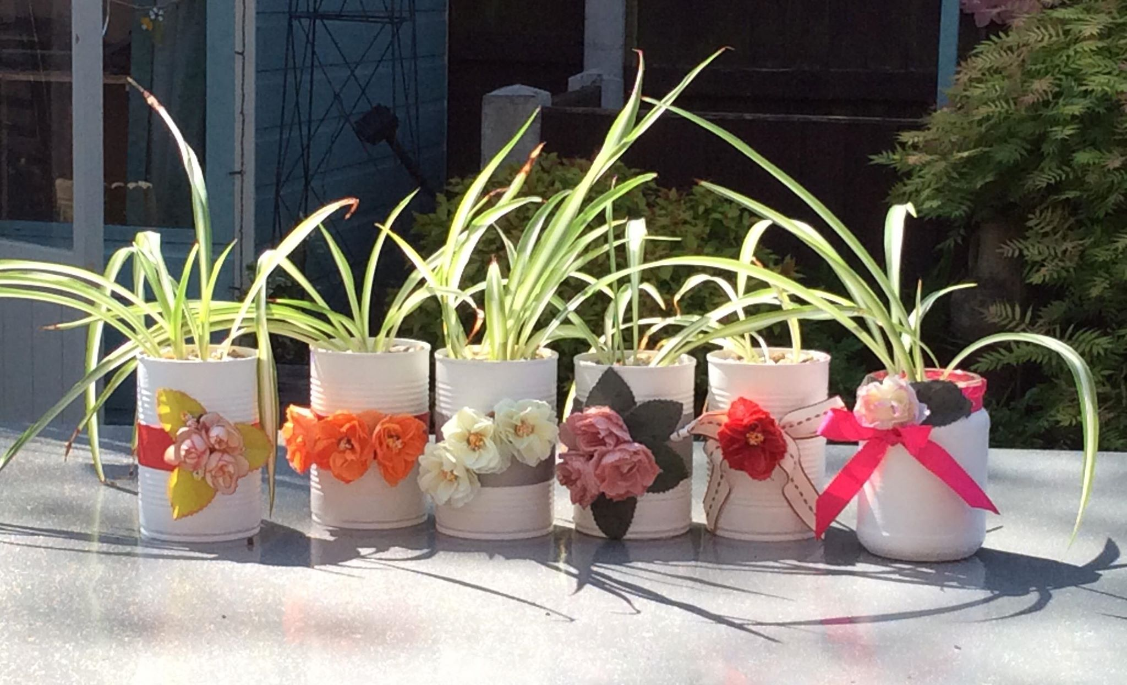
Tracey.....has been busy crafting, up-cycling some cans and jars to sell at a plant sale we hope to have later in the year! Do you know what plants these are? Clue:- These creepy crawlies have 8 legs!
We hope you are all well and being as good as we know you can be. Be kind to each other and keep looking on the website for the next newsletter!

