Here some art activities to keep you all busy!

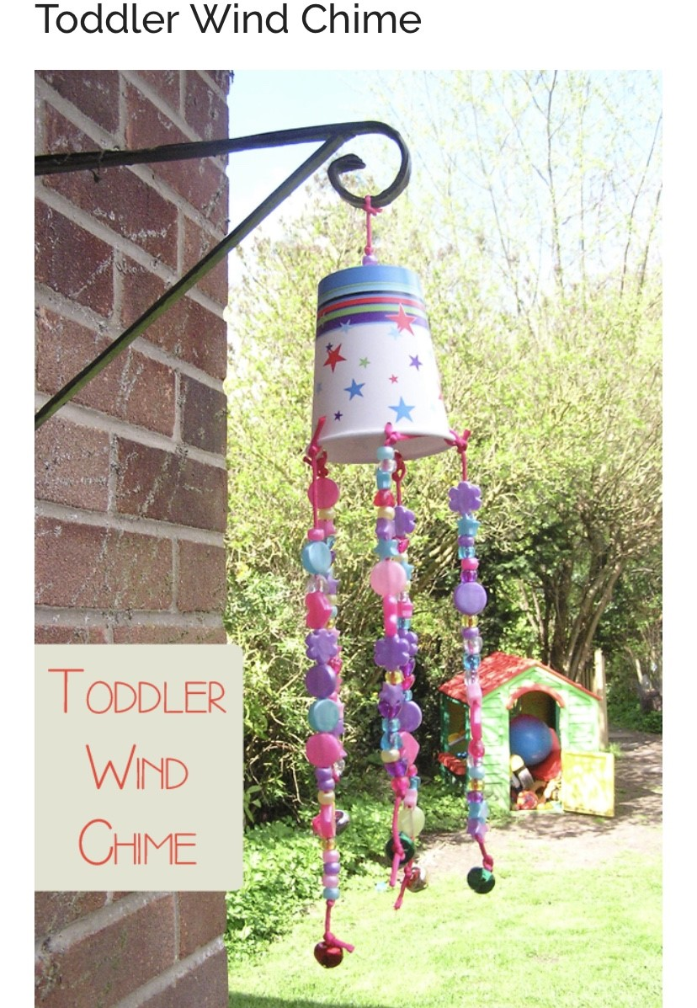
This is a really simple yet effective activity; all you need is some paper cups, string and beads.

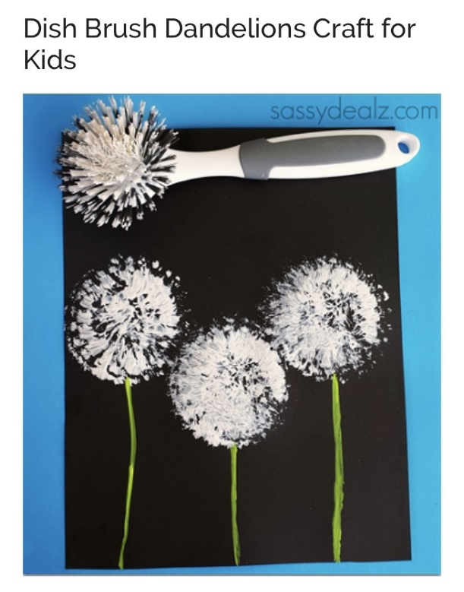

I love this painting using an old washing up brush.

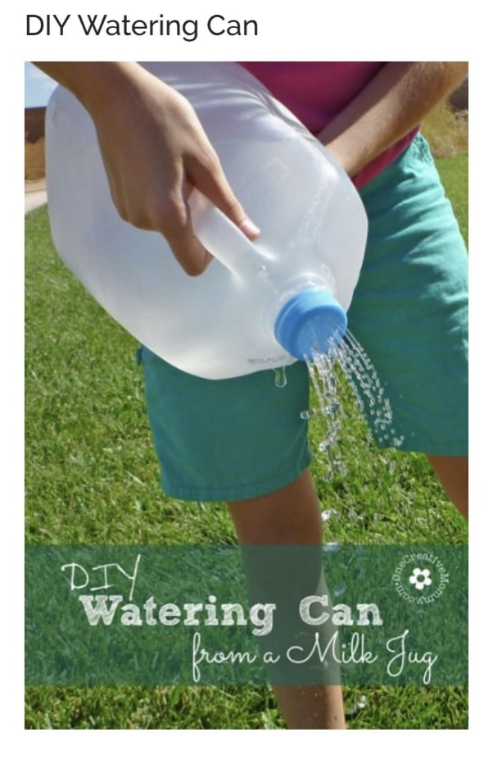

I bet you all have an old milk bottle in your recycling; why not turn it into a watering can! I’m sure your parents or careers will be very happy if you can help with watering the plants!

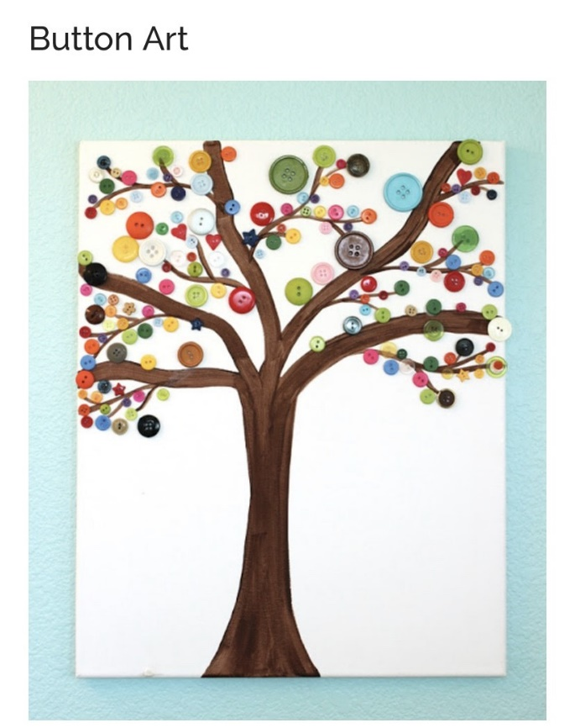

If you have any spare buttons why not use them to create a lovely picture. Here the buttons have been used as leaves on the tree.

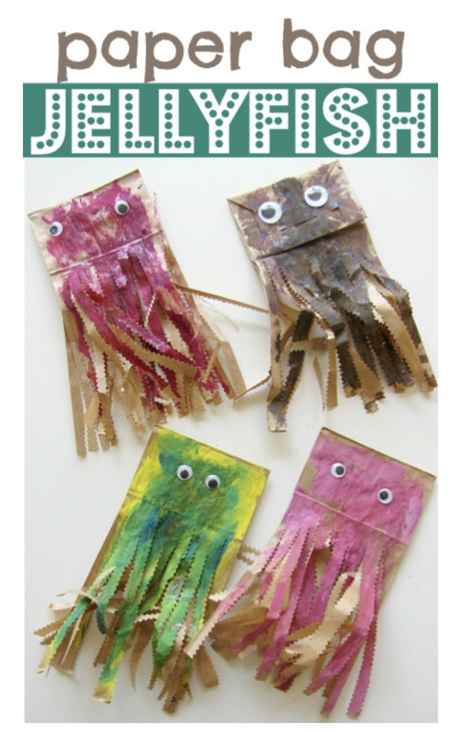

I just love these fun jellyfish, you could paint them whatever colour you want and use some googly eyes if you have any! Once painted all you need to do it cut the bottom of the bag into strips. If you have any string you could hang these up in your bedrooms and watch them wobble and dance around.

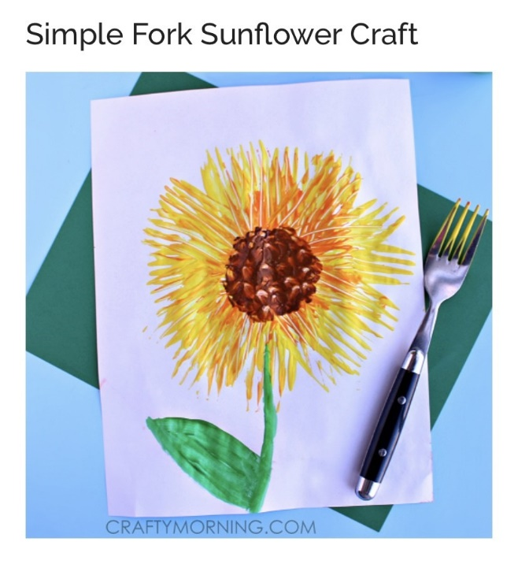

This sunflower is so happy and could cheer anyone up! All you need is a folk and some paint, just need to dip the folk into some orange/yellow paint and print with it!

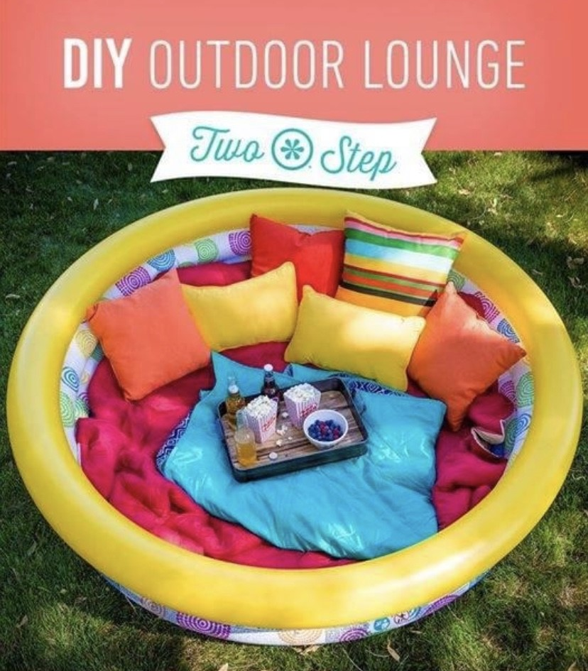

After all this creativity, I bet you will need somewhere to chill and enjoy the sunshine. This paddling pool looks like the perfect place to relax, fill the pool with some blankets and cushions and maybe grab a book and you’re set!

