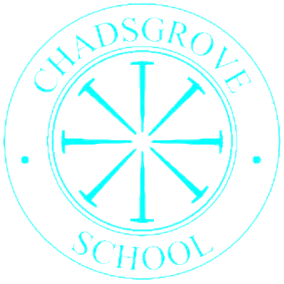

Chadsgrove Curriculum Cross Curricular Topics:

Pioneers 1

|  |  |  |  |  |  |  |
| --- | --- | --- | --- | --- | --- | --- |
|  | **Autumn** | | **Spring** | | **Summer** | |
|  |  | | | | | |
| ***Values*** | *Welcoming and Friendship* | *Fun and Independence* | | *Trust and Teamwork* | |
| **2025** | Africa | **2026** | Our Community  Britain | **2026** | Celebrations  Food and Drink |
| **2026** | Victorian Britain | **2027** | The Human Body | **2027** | Asia |
| **2027** | How Things Move and Work | **2028** | Mysteries  Time Travel | **2028** | Rivers and Coasts |