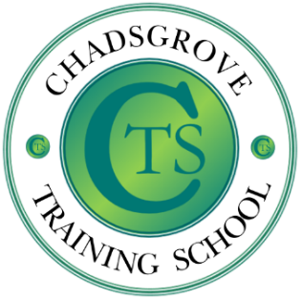
Course led by Leigh Blakeman, Senior Mental Health Lead, Curriculum Lead and Tutor, Chadsgrove College & School. Leigh has holistic therapy qualifications; She has completed the Department for Education funded Senior Mental Health Lead as well as being a Mental Health First Aider. She also has personal experience that inspires her to raise awareness in this area.

Leigh Blakeman has a BA Hons in English language/literature and Drama, she worked as a corporate professional, first starting in educational practice in 1993 as an NVQ assessor. This led to further training as an FE tutor with a specialism in Holistic therapies, well-being practices and English. Leigh has delivered holistic and well-being workshops for students and education staff across the Midlands and London boroughs. She has been at Chadsgrove School in Worcestershire for eleven years; to begin with, as a part time holistic therapy tutor; she soon realised that education within the SEN sector was to become her primary focus. Currently she is a curriculum lead and Senior Mental Health Lead based at Chadsgrove Education Trust College. This is a specialist college provision for students aged between 19-25, that provides a tailored curriculum focused around the Preparing for Adulthood pathways for students with PMLD, severe learning disabilities and complex needs. Leighs passion is to utilise professional training, knowledge and personal experience to enable and empower others.
Understanding how to support learners and staff following a bereavement can be extremely challenging. We will be aiming to help remove the fear factor around dealing with grief through building confidence to approach and support appropriately.
Teachers and Support Staff
Tuesday 14th May, 10.00am to 12.00
At Chadsgrove School
£65 per delegate
Bereavement
Offering Effective Support During Times of Grief
This training will be face to face.

Please complete and return the booking form overleaf or contact the school
Email: courses@chadsgrove.worcs.sch.uk
Tel: 01527 871511
Chadsgrove Training School
Professional Development

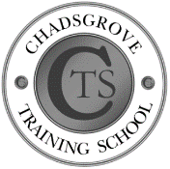
Chadsgrove Training School

Course Title: Bereavement Training Date: 14.5.2024
(Course led by: Leigh Blakeman)
Number of Places Required (@£65 each):
Attendee(s) Name & Email Address

The information you provide in this form will be used solely for processing your course booking. If you wish us to retain your email address to contact you about future CTSA professional development opportunities please tick this box
Occupation:
Special Requirements:
(e.g. dietary, access, etc.)
Organisation name:
Postal Address for Correspondence:
Invoicing Address (if different to Postal Address):

Email:
Telephone Number:
Total Cost:

(Please make cheques payable to Worcestershire County Council)
Cost Centre for Internal Transfer for Worcestershire Schools. Please complete both sections below.

Project Code: Cost Centre:
Authorised Signature (Headteacher): | Name:
We regret that we cannot accept typed signatures. Digital signatures or scanned electronic copies are suitable.
Please return to:
Chadsgrove Training School, Meadow Road, Catshill, Bromsgrove, Worcestershire, B61 0JL

Tel: 01527 871511 Email: courses@chadsgrove.worcs.sch.uk
In the event of unforeseen circumstances we reserve the right to cancel or alter parts of the programme.

