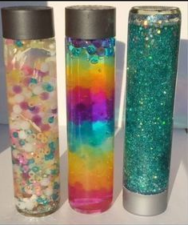
Space Water Bottle
You will need:
- Plastic bottle or jar
- Water
- Food colouring/dye
- Glitter/sequins/water beads/glitter glue
Method:
- Add water until it reaches just over half way
- Add glitter/sequins/water beads/glitter glue
- Add a few drops of food colouring/dye
- Screw lid on and shake!
- Add more water until it is ¾ full. Leave a gap to allow the mixture to move around.
- (optional) glue the lid down to prevent spillage.
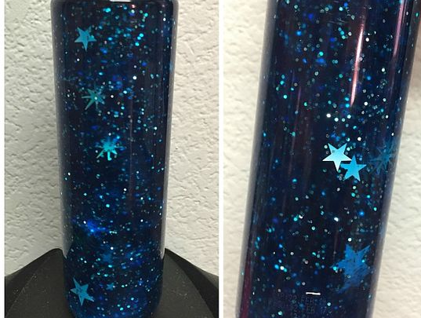
- Shake and enjoy!

